|  |  |  |  |
| --- | --- | --- | --- |
|   *Session* :  **Juin 2023**  Code :  **ABA-SM-MDW-1** | **M**inistry **o**f **H**igher **E**ducation **a**nd **S**cientific **R**esearch  **D**irectorate **G**eneral **o**f **T**echnological **S**tudies  **H**igher **I**nstitute **o**f **T**echnological **S**tudies **o**f **N**abeul  *Information Technology Department*  **END OF STUDIES PROJECT**   |  | | --- | | **Specialty:** *Multimedia and Web Development* |  |  | | --- | | **Creation and Development**  **of 3D Online Multiplayer Mobile Game** |   **Directed by:**  **Souhail Mihoubi**  **Abderrahmen ben Aissa**    **Host organization: Framed by:**  CGI Studio Ms. Salima Mnif  Mr. AmenAllah ben Achour  **Academic year:**  **2022 – 2023** |

*Dedicatee*

*"To her, who gazes at the sun with frozen eyelids and holds fire with cold fingers... and to her, who digs into the forehead of the sea with icy staffs... and to her, who weaves the roof of love from threads of air... and to her, who plays on the guitar of the winds...* ***to “Nounou” the sister of the soul."***

*“To my siblings* ***Amen & Raki****, as your big brother I hope that I made a clear way for you to follow, I dedicate this for you, dream big, follow your dreams and shine.*

*“To the guiding light in my life, to the pillar of strength , the ones who has guided me with wisdom and taught me invaluable lessons,* ***my beloved parents****. Your unwavering support, sacrifices, and belief in me have shaped me into the person I am today. I dedicate this success to you.”*

*“To my incredible partner in this project,* ***Souhail****.*

*I want to express my deepest appreciation and admiration for your unwavering dedication and collaborative spirit. From the very beginning, collaborating with your unique talent we have embarked on this journey together, and your commitment and hard work have been nothing short of remarkable.”*

*“To my* ***friends*** *and to everyone who’ve been there with me when I felt down, we’re in this journey together, your support is very much appreciated, and I hope I’m able to be as motivational and supportive as you. Keep existing!”*

***Abderrahmen Ben Aissa.***

***Dedicatee***

*I would like to dedicate this report to the incredible individuals who have been instrumental in my academic journey.*

*To my loving parents,* ***Kamel*** *and* ***Aicha****, your unwavering support and belief in my abilities have been the driving force behind my success. Your sacrifices and dedication to my education have shaped me into the person I am today. This achievement is a reflection of your endless love and encouragement.*

*To my siblings,* ***Souha*** *and* ***Soufien****, you have been my lifelong companions, offering guidance, laughter, and unconditional support. Your presence has made every step of this journey more meaningful, and I am grateful to have you by my side.*

*To my partner,* ***Abdou****, thank you for being my rock, my confidant, and my biggest cheerleader throughout this challenging endeavour.*

*To* ***Wissem*** *&* ***Med Hedi*** *and all my friends, both near and far, thank you for being a part of my life's journey. Your support, laughter, and companionship have enriched my experiences and made them more meaningful. I am grateful for the countless memories we have created together.*

*And to* ***Yossri****, a special dedication. Your unwavering friendship, encouragement, and shared moments have made a profound impact on my life. Thank you for being a constant source of support and for being there through thick and thin. Our bond is cherished, and I am grateful to have you as a friend.*

*“Last but not least,* ***I wanna thank me****.*

*I wanna thank me for believing in me.*

*I wanna thank me for doing all this hard work.*

*I wanna thank me for having no days off.*

*I wanna thank me for, for never quitting”.*

***Souhail Mihoubi***

***Appreciation***

*We would like to express our sincere gratitude to our academic supervisor, Ms. Salima Mnif, for supervising and examining our work, as well as for her valuable advice and insightful reflections that guided us in completing this project.*

*We also want to extend our heartfelt thanks to our supervisor, Mr. Amen Allah BenAchour, for the honor of working with his team, for the time he dedicated to us, and for his assistance throughout the internship period. It is thanks to his kindness that we had the opportunity to quickly integrate into CGI STUDIO.*

*Lastly, we would like to convey our sincerest greetings to the members of the jury. It is an honor to accept the invitation to participate in the evaluation of this project.*

**Table of contents**

Project Framework 2

1.1 Presentation of host organization 2

1.1.1 Host organization 2

1.1.2 Business area 2

1.1.3 Company Organization Chart 3

1.2 Project Objectives 4

1.2.1 General Context 4

1.2.2 Problematic 4

1.2.3 Proposed Solution 4

1.3 Development process 4

1.4 State of the Art 5

1.4.1 Overview of the video game industry 5

1.4.2 Competitor Analysis 5

1.5 Choice of 2D/3D techniques 6

1.6 Existing Study 6

1.6.1 Description of the existing games 6

1.6.2 Critique analysis of the exiting games 7

1.7 Methodology and Project Planning 8

1.7.1 Agile Adopted Methodology 8

1.7.2 The Scrum Method 8

1.7.3 Why Scrum for Game Development 9

1.7.4 Scrum Actors in Our Project 9

1.7.5 Implementing Scrum Methodology 9

1.7.6 Sprint planning 10

Requirements Specification 14

2.1 Functional and non-functional requirements 14

2.1.1 Functional requirements 14

2.1.2 Non-functional Requirements 16

2.2 Game Synopsis 17

2.3 Navigation Scheme 17

2.4 Global Use Case Diagram 18

2.5 Activity Diagrams 19

2.5.1 Player’s Activity Diagram 19

2.5.2 Player in-game activity diagram 20

2.6 Class Diagrams 21

2.6.1 Global Class Diagram 21

2.6.2 Class diagram that represents the “Player” 24

2.6.3 Class diagram that represents the “Enemy” 26

2.6.4 Class Diagram that represents the “Attack” use case 27

2.6.5 The User Interface Class Diagram 28

Development 30

3.1 Work Environment 30

3.1.1 Hardware Environment 30

3.3.2 Software Environment 31

3.3.3 Platforms and Libraries 32

3.3.4 Programming and modeling languages 33

3.2 Timeline 34

3.3 Sprint Development Process 35

3.3.1 Sprint 1: “3D Modelling” 35

3.3.1.1 Enhancing Player Experience 35

3.3.1.2 Development of Sprint 1 36

3.3.1.2.1 Conceptualization 37

3.3.1.2.2 Modeling 37

3.3.1.2.3 UV Mapping 40

3.3.1.2.4 Texturing 40

3.3.1.2.5 Rigging 42

3.3.2 Sprint 2 “UI Design” 46

3.3.2.1 User-centered Design? 46

3.3.2.2 Detailed conception of the sprint 2 46

3.3.2.2.1 Use case diagrams of the sprint 2 47

3.3.2.3 Development of sprint 2 58

3.3.3. Sprint 3: “Animations & controls” 62

3.3.3.1 Detailed conception of the sprint 3 62

3.3.3.1.1 Use case diagrams of the sprint 3 62

3.3.3.1.2 Sequence diagram of the matmaking process 69

3.3.3.2 Development of sprint 3 70

3.3.3.2.1 Animation 70

3.3.3.2.2 Animation our “Hunters” 71

3.3.3.2.3 Implementing Photon Network set-up 75

3.3.3.2.4 PlayFab implementation 77

.3.3.2.5 In-game User Interface 78

3.3.4 Sprint 4 “Authentication & Game Enhancement” 81

3.3.4.1 Detailed conception of sprint 4 81

3.3.4.2 Development of sprint 4 83

3.3.4.2.1 PlayFab utilization 83

3.3.4.2.2 Implementing Game Audio 84

3.3.4.3 Game Deployment 85

**Table of figures**

Figure 1. 1 CGI Studio logo 2

Figure 1. 2 Organization Chart 3

Figure 1. 3 2022 Global Games Market 5

Figure 1. 4 Magic.io game 7

Figure 1. 5 Clash Royale game 7

Figure 1. 6 Scrum Architecture 8

Figure 2. 1 Global Use Case Diagram 18

Figure 2. 2 Player's activity diagram 19

Figure 2. 3 Player in-game activity diagram 20

Figure 2. 4 Global Class Diargam 21

Figure 2. 5 "Player" Class Diagram 24

Figure 2. 6 "Enemy" Class Diagram 26

Figure 2. 7 "Attack" Class Diagram 27

Figure 2. 8 "UI" Class Diagram 28

Figure 3. 1 Unity logo 31

Figure 3. 2 Visual Studio logo 31

Figure 3. 3 Blender logo 31

Figure 3. 4 Mixamo logo 31

Figure 3. 5 Diagrams logo 32

Figure 3. 6 Photoshop logo 32

Figure 3. 7 PlayFab logo 32

Figure 3. 8 Photon logo 32

Figure 3. 9 C# logo 33

Figure 3. 10 UML Logo 33

Figure 3.11 UI design schedule on Trello 35

Figure 3. 12 Monochromatism Colour Palette 36

Figure 3. 13 Low Poly and High Poly 38

Figure 3. 14 Modifiers used to create 3D models 39

Figure 3. 15 Base Mesh of the characters 39

Figure 3. 16 Map & 3D object base mesh. 40

Figure 3. 17 8bit Colour Palette 41

Figure 3. 18 Material Creation 41

Figure 3. 19 Texture Mapping 42

Figure 3. 20 Character Rigging in Mixamo 43

Figure 3. 21 The skeleton of the character 43

Figure 3. 22 Final rendered and rigged characters 44

Figure 3. 23 Nature Map 44

Figure 3. 24 City Map 44

Figure 3. 25 Map Terrain 45

Figure 3. 26 Finalized Map example 1 45

Figure 3. 27 Finalized Map example 2 45

Figure 3. 28 Sprint 2 use case diagram 47

Figure 3. 29 Authenticate use case diagram 47

Figure 3. 30 "Access to main menu" use case diagram 49

Figure 3. 31 Select map sue case diagram. 50

Figure 3. 32 Check message of the day use case diagram 51

Figure 3. 33 Access to settings use case diagram 52

Figure 3. 34 Access to hunters panel use case diagram 53

Figure 3. 35 Check leaderboard use case diagram 54

Figure 3. 36 Access to profile panel use case 55

Figure 3. 37 Start game use case diagram 56

Figure 3. 38 Authentication interface 58

Figure 3. 39 Main Menu Interface 58

Figure 3. 40 Notification recieved 59

Figure 3. 41 In-game message 59

Figure 3. 42 Leaderboard 59

Figure 3. 43 Settings panel 59

Figure 3. 44 Hunters panel 60

Figure 3. 45 Profile panel 60

Figure 3. 46 Shop panel 60

Figure 3. 47 Matchmaking menu 61

Figure 3. 49 Play with friends menu 61

Figure 3. 48 Waiting for other player menu 61

Figure 3. 50 Sprint 3 Use Case 62

Figure 3. 51 Move hunter use case 63

Figure 3. 52 "Attack" Use Case 63

Figure 3. 53 "Heal up" Use Case 64

Figure 3. 54 “Collect experience points and coins” Use Case 65

Figure 3. 55 “upgrade in-game character capabilities” Use Case 66

Figure 3. 56 "Adjust in-game settings" Use Case 67

Figure 3. 57 "Chat" Use Case 68

Figure 3. 58 Matchmaking process sequence diagram 69

Figure 3. 59 Hunters animation process 71

Figure 3. 60 Unity Asset Store logo 73

Figure 3. 61Monsters pack 73

Figure 3. 62 NavMesh in the Map 74

Figure 3. 63 NavMesh Agent Collider 75

Figure 3. 64 Photon Network Application Form 75

Figure 3. 65 Photon Dashboard 76

Figure 3. 66 Implement Photon in Unity 76

Figure 3. 67 PlayFab Applications Dashboard 77

Figure 3. 68 PlayFab in Unity 77

Figure 3. 69 imported librairies 78

Figure 3. 70 PlayFab Dashboard 78

Figure 3. 71 Game User Interface 79

Figure 3. 72 Victory panel 79

Figure 3. 73 Loss panel 80

Figure 3. 74 Player eliminated panel 80

Figure 3. 75 Sequence Diagram of Authentication 82

Figure 3. 76 Audio Source in Unity 84

Figure 3. 77 Website Interface 85

Figure 3. 78 "About" Page 85

Figure 3. 79 "Trailer" Page 86

Figure 3. 80 "Download" Page 86

Figure 3. 81 "Contact Us" Page 87

Figure 3. 82 Reset Password Email 88

Figure 3. 83 "Reset Password" Page 88

**List of tables**

Table 1. 1 Information sheet of the company 2

Table 1. 2 Backlog Product 10

Table 3. 1 Hardware Environments 30

Table 3. 2 Timeline table 34

Table 3. 3 "Authenticate' Description table 48

Table 3. 4 "Access to main menu' Description table 49

Table 3. 5 "Select map" Description table 50

Table 3. 6 "Check message of the day" Description table 51

Table 3. 7 "Access to settings" Description table 52

Table 3. 8 "Access to hunters" Description table 53

Table 3. 9 "Check leaderboard" Description table 54

Table 3. 10"Access Profile" Description table 55

Table 3. 11 " Access settings" Description table 56

Table 3. 12 "Move hunter" Description table 63

Table 3. 13 "Attack" Description Table 64

Table 3. 14 "Collect experience points and coins" Description table 65

Table 3. 15 “upgrade in-game character capabilities” Description table 66

Table 3. 16 "Adjust in-game settings" Description table 67

Table 3. 17 "Chat" Description table 68

**General Introduction**

Games have become an important part of society by influencing entertainment, education, social interaction, and more. As technology continues to advance, it is likely that games will continue to evolve and have an even greater impact on society in the coming years, and that’s why, behind every great game is a team of game developers who work tirelessly to create immersive worlds, compelling characters, and challenging gameplay mechanics.

In recent years, mobile gaming has become an increasingly popular way to enjoy video games on the go. One type of mobile game that has seen significant growth in popularity is the role-playing game, or RPG. These games offer players a chance to explore immersive worlds, engage in exciting battles, and level up their characters over time.

Mobile RPGs offer a convenient and accessible way for players to enjoy immersive gaming experiences everywhere and anytime and as mentioned before, the technology continues to evolve, we will see more exciting and innovative RPG games in the future.

The company entrusted us with the creation of a 3D RPG android mobile game. This report summarizes the work that has been carried out during our internship at CGI STUDIO, and we will describe its various components in detail through three chapters.

* **The first chapter** will present an overview of the organization undertaking the project, project objectives, development process, state of the art, choice of 2D/3D technique, existing analysis, and planning.
* **The second chapter** outlines the specific functional and non-functional requirements for the game, provides an overview of the game's storyline and navigation scheme, presents a use case diagram, and provides a detailed explanation of the primary activities through a major use case and activity diagrams.
* **The last chapter** describes the work environment, timeline, and sprint development process, which involves breaking the project into smaller sprints with detailed design, development, and testing plans.

**Chapter 1**

# Project Framework

## Presentation of host organization

1.1.1 Host organization

**The internship takes place within the company CGI Studio, a professional computer office specializing in developing PC and mobile video games. It’s located in Menzel Temime, Nabeul.

Figure 1. 1 CGI Studio logo

It was founded in 2018 by Mr. Amen Allah Ben Ashour

Table 1.1 provides an information sheet on CGI Studio.

1.1.2 Business area

CGI STUDIO is an IT company that operates in the video game industry and the economic sector of designing, producing, and marketing video games. Its areas of activity:

Table 1. 1 Information sheet of the company

|  |  |
| --- | --- |
| **Company Name** | CGI STUDIO |
| **Creation Date** | 05/07/2018 |
| **Legal Status** | Individual company |
| **Activity Area** | IT Activities |
| **Activities Headquarters** | 1 Moussa Ben Noussair Menzel Temime 8080  Mobile APPS, 3D Animation, AR, VR, Video-games development, Architecture, design, AI. |
| **E-mail** | cgistudio.contact@gmail.com |

1.1.3 Company Organization Chart

The company is composer of two main hierarchical components described in the figure 1.2.

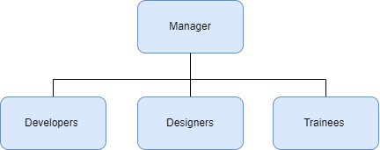

Figure 1. 2 Organization Chart

**The Manager's mission:**

* The preparation of work and the implementation of decisions made by the board of directors.
* Representing the company to third parties and taking responsibility for the signature of civil, administrative, and legal documents.

**The Developer’s mission:**

* Creating the specifications document.
* Translating the specifications into code with the goal of making them faster and more efficient.
* Programming interfaces and associated tools, menus, and actions.
* Correcting errors and making necessary modifications.

**The Designer's mission:**

* Interpreting requests made verbally or in writing in the specifications document.
* Imagining the potential for transforming submissions.
* Creating digital 3D models, animations, and image processing.

**The Designer's mission:**

* Interpreting requests made verbally or in writing in the specifications document.
* Imagining the potential for transforming submissions.
* Creating digital 3D models, animations, and image processing.

## Project Objectives

* + 1. General Context

We aim to create an open-world 3D mobile game in a third-person perspective. It is in this context that our end-of-year project finds its essence which are:

design, development, and realization of a 3D video game.

* + 1. Problematic

How can we overcome the challenge of creating a successful video game in the Tunisian market, which is still in its early stages, and expand it to a global market?

The task assigned by the company to design, develop, and produce a video game poses a unique challenge that requires careful consideration of the local market's characteristics, user preferences, and trends, as well as the competition in the global market.

* + 1. Proposed Solution

The objective of this project is to develop a mobile game that is engaging and addictive for players and to provide a game that is fun and immersive, and promoting responsible gaming practices.

It is an RPG 3D online game in a third-person perspective, with the theme of low-poly worlds, battel royale and survival, where 4 players get spawned on a map and battle AI generated and controlled bot enemies. As the game ends, the last-standing player will be announced to be the winner of the match.

We have chosen the name “Let’s Hunt” for this video game.

## Development process

The development process for our game will follow an agile approach, allowing flexibility throughout the project. This approach emphasizes good collaboration and communication among the team, with regular check-ins and sprints to ensure that progress is being made.

The development process consists of different stages which are conception, 3D modelling, programming, testing and validation. Each stage will be executed in a sequence leading us to realizing that the outcome of one stage will be used as an input that insures the start of the next stage.

Overall, bringing our vision to life will surely depend on how the development process is smoothly progressing.

## State of the Art

In This section we define an overview of the current state of the gaming industry, as well as any existing research or studies that are relevant to the project.

* + 1. Overview of the video game industry

**Mobile gaming** has gone from the smallest Gaming market segment in 2012 to one of the world's most successful industries in 2023 as mobile penetration rates and smartphone usage continues to accelerate globally, mobile gaming revenues are on track to exceed $100 billion by the end of 2023 according to a report by Newzoo.

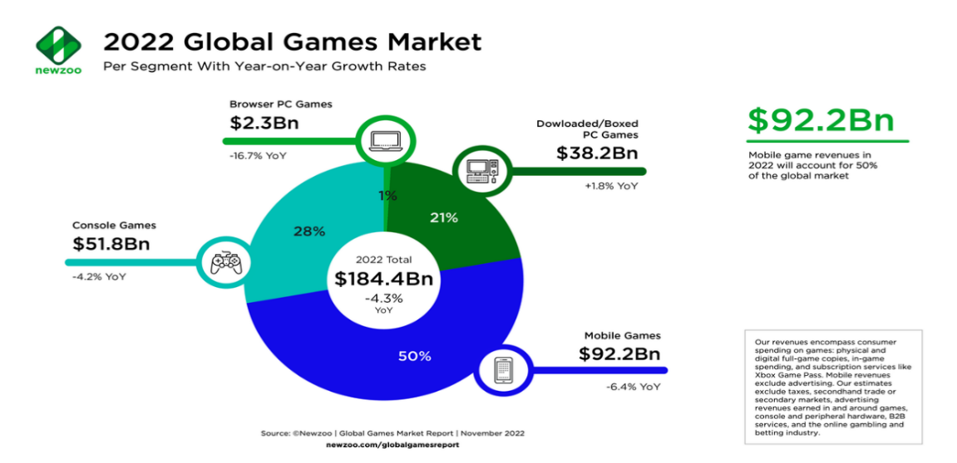

Figure 1. 3 2022 Global Games Market

* + 1. Competitor Analysis

To succeed in the highly competitive video game market, it is important to understand it thorough analysis of the competition which will provide insights into the strengths and weaknesses of the existing RPG games.

The video game industry is highly competitive when there’s major competitors such as Microsoft, Sony and Nintendo dominating the console market, while mobile gaming continues to grow with games such as “Candy Crush”, “Free Fire” and many other popular games.

So, understanding the current state of the video games industry is important in developing a successful mobile game that can be locally and why not world widely known.

## Choice of 2D/3D techniques

The decision on either to use 2D or 3D graphics in a video game development is confusing, as it affects the overall look and feel of the game, also its performance and development time and effort, though 2D graphics are typically easier to create and faster to develop, 3D graphics can offer a more immersive and visually beautiful experience for the players.

after discussing and understanding our basics and needs we then chose to work with 3D models because while the 2D games can be great in their own way, 3D games offer several advantages that makes it more desirable.

Firstly, the use of three-dimensional graphics provides a sense of depth and a realism which enhances the player’s sense of being in the game environment world.

Another advantage of 3D games is the ability to create dynamic environments, landscapes buildings and many different objects with many details than is possible with 2D graphics.

In addition, 3D games development comes with its own set of challenges, such as the need for more advanced hardware and software, and the complexity of designing and implementing three-dimensional graphics.

Ultimately, the decision between 2D and 3D graphics comes to the specific need and goal of the game.

Finally, we chose to produce a 3D game on our own and it was observed to be as a challenge for ourselves.

## Existing Study

* + 1. Description of the existing games

To better understand the current state of mobile RPG games and identify potential areas of improvement, we conducted a study of existing games on the market.

We analysed the gameplay mechanics, visual design, user interface, and monetization strategies of several popular RPG games, including ‘Magica.io’ and ‘Clash Royal’. Through this study, we identified certain strengths and weaknesses in each game, such as an engaging a network system like “Magica.io” but a cluttered user interface in Clash Royal. This information will inform our own game design and inspire us to create a product that stands out in the competitive mobile gaming market.

**Magica.io**

Magica.io is a mobile Battle Royale game for true leaders! Smash other players on the battle arena and conquer the leaderboard charts! Fight for survival in great battles, collect epic loot, improve your character's fighting skills.

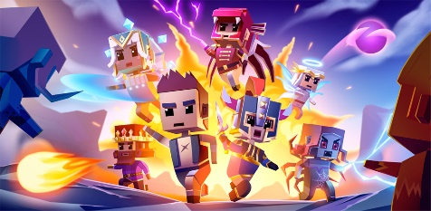

Figure 1. 4 Magic.io game

**Clash Royale**

Clash Royale is a free-to-play real-time strategy video game developed and published by Supercell. The game combines elements from collectible card games, tower defense, and multiplayer online battle arenas. The game was released globally on March 2, 2016.

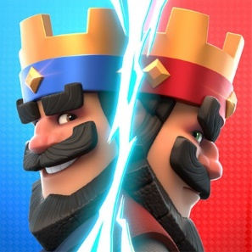

Figure 1. 5 Clash Royale game

* + 1. Critique analysis of the exiting games
* **Clash Royale**
* The game heavily relies on the luck of card draws, making matches feel unfair at times.
* Progression in the game can be slow without spending money on in-app purchases.
* The matchmaking system sometimes pairs players with opponents who are much stronger or weaker, leading to frustrating matches.
* The game's community can be toxic and unwelcoming to new players.
* **Magica.io**
* The game's controls can be difficult to master, leading to frustration for new players.
* Matches can sometimes feel unbalanced due to the random nature of power-up spawns.
* The game lacks depth in terms of strategy and gameplay mechanics.
* The game's graphics and sound design may not be appealing to some players.

## Methodology and Project Planning

A methodology provides good structure and organizes the development process.  
By following a set of tasks and making a right way and adhering a detailed plan that helps us to keep a good track during this journey.

For our project, we have chosen a methodology that allows us to adjust our development plan as needed.

* + 1. Agile Adopted Methodology

The Agile methodology is a way to manage a project by breaking it up into several phases. It involves constant collaboration with stakeholders and continuous improvement at every stage. Once the work begins, teams’ cycle through a process of planning, executing, and evaluating. The idea is to achieve the result defined by the project objectives in small steps mastered and practical.

* + 1. The Scrum Method

“Scrum is an Agile project management methodology involving a small team led by a Scrum master, whose main job is to remove all obstacles to getting work done. Work is done in short cycles called sprints, and the team meets daily to discuss current tasks and any roadblocks that need clearing.”

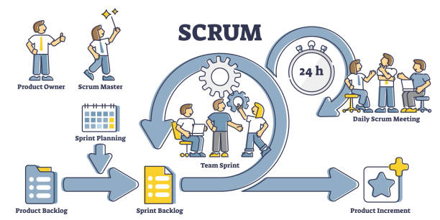

Figure 1. 6 Scrum Architecture

1.7.3 Why Scrum for Game Development

Scrum and agile methods are popular approaches in video games development because they involve regular evaluations of plans and iterative work phases, so by adopting such an approach we can minimize the risk of errors showing up during the programming phase, not to mention that the game industry is rapidly changing trends, so we must keep up with these changes.

Choosing a Scrum team for game development makes the work always up to date and ready for any kind of change or upgrade leading to good use of resources and time in creating the game.

* + 1. Scrum Actors in Our Project

The actors in our project are:

**Product Owner and Scrum Master**: *AmenAllah BenAchour.*

**Development Team**: *Abderrahmen Ben Aissa & Souhail Mihoubi.*

* + 1. Implementing Scrum Methodology

Since we are using Scrum, it will help us organize our work into manageable sprints.

**Sprint 1: 3D Modeling**

* Character creation.
* Maps creation.

**Sprint 2: User Interface design**

* UI/UX design.

**Sprint 3: Animations & Controls**

* Hunter & Enemy animating and controls.
* Implement Photon Network set-up.
* PlayFab implementation.
* In-game user interface.

**Sprint 4: Authentication & Game Enhancement**

* Authentication and login.
* Adding SFX and music to the game.
* Test and debug the game.
* Finalize and publish the game.

By following this approach, we could effectively manage our game development project and deliver a quality product within the specified timeline.

* + 1. Sprint planning

The life of a Scrum project is punctuated by a set of precisely defined and time-boxed meetings.

**The Sprint** is an iteration. It is a period of 2 to 4 weeks maximum during which a finished and usable version of the product is produced. A new sprint starts right after the previous one ends, and each sprint has a goal and a list of features to be completed.

**Sprint Planning** represents the tasks to be accomplished during the Sprint are determined by the entire Scrum team during the Sprint Planning meeting. The duration of this meeting is limited to 8 hours for one-month Sprints. This meeting allows us to establish the items we will be working on during this Sprint and how it will proceed.

**The product backlog** is a prioritized list of the client's initial requirements regarding the product to be developed. This document constantly evolves during the project, based on the client's needs. The product owner is responsible for the product backlog.

**The Sprint backlog** is the detailed plan for achieving the Sprint goal, defined during the Sprint Planning meeting and it is regularly updated by the team to have a precise view of Sprint’s progress.

Table 1. 2 Backlog Product

|  |  |  |  |  |
| --- | --- | --- | --- | --- |
| **ID** | **Sprint** | **User Story** | **Sprint Backlog** | **Priority** |
| **1** | **3D Modelling** | As a player I want to play with good looking 3D game characters. | * Learning Blender and 3D character modeling. * Learning and practicing 3D objects Modeling. | High |
| As a player I want to play on different 3D maps. |
| **2** | **User Interface Design** | As a player I want to check game news and be notified with every update. | * Practicing photoshop and design skills. * Learning the mood building and emotional impact of colors on player’s behavior. * Design and develop a user-friendly and attractive user interface. * Develop the game settings menu. * Think of a feature to store player’s data and track player stats in the game. | High |
| As a player I want to access the game settings. |
| As a player I want to check the game leaderboard to know my ranking in the game. |
| As a player I want to have access to the shop menu. |
| As a player I want to have access to own, select and buy my game character. |
| As a player I want to have access to edit my profile username and avatar. |
| As a player I want to know my profile stats. |
| As a player I want to navigate through a user-friendly and adaptive user interface. |
| **3** | **\***  **Animation & Controls** | As a player I want to be able to choose the matchmaking mode. | * Implement Photon networking SDK. * Set-up matchmaking modes. * Create in-game characters controls, movements, and animations. * Create AI character movement, controls, and navigation pattern through the maps. * Develop AI enemy behavior. * Create basic enemy animations. * Develop in-game chat system. * Implement loot drop system. * Develop player abilities upgrade system. * Implement real-time notification for defeated players. * Set-up basic in-game settings panel. * Create scoreboard, kills and ranking system. | High |
| As a player I want to play on a well-developed networking system. |
| As a player I want to move my hunter around the map using a joystick. |
| As a player I want to attack enemies. |
| As a player I want to be rewarded when I kill an enemy by receiving coins and XP. |
| As a player I want to level up and upgrade my in-game character abilities. |
| As a player I want to heal my in-game character when I get damaged by enemy’s attacks. |
| As a player I want to chat with the players in the room. |
| As a player I want to access in-game music and SFX settings. |
| As a player I want to be kept on track with the scores of all the players with me, through a live in-game scoreboard. |
| As a player I want to be notified when another player is defeated. |
| 4 | **Game enhancement & deployment**. | As a player I want to securely authenticate by signing up and logging in. | * Implementation of PlayFab. * Creation of login and register panel. * Development of email verification. * Storing player’s data on PlayFab. * Adding sounds and music to the game. * Creation of a website for the game publishment. | High |
| As a player I want to verify my account via email verification. |
| As a player I want to enjoy good music and SFX experience. |
| As a player I want to be able to download the game from the official online website |

**Chapter 2**

# Requirements Specification

## 2.1 Functional and non-functional requirements

2.1.1 Functional requirements

“In software engineering and systems engineering, a functional requirement defines a function of a system or its component, where a function is described as a specification of behavior between inputs and outputs.’’ [1]

Below, we list the functionalities that the player can perform:

**Authenticate**

* The player can either Login or create an account with the Playfab authentication service when they start the game.

**Access to main menu**

* The player can access the main menu where he will interact with an interface.

**Access to settings**

* By clicking the "settings" button, the player can access the appropriate interface where they can adjust the music, SFX, or choose a graphics quality.

**Access to coins and gems shop**

* By clicking the “shop” button, the player can access the shop panel where he can buy coins and gems.

**Access to Hunter panel**

* The player can access the hunters panel where he can buy or select a character.

**Access to profile panel**

The player can access the profile panel to see and change his profile name and avatar and check his in-game stats such as the number of matches played, hunters owned, most favorite hunter

**Access to Leaderboard**

* The player can access the leaderboard to see and search his ranking between all the players saved on the database.

**Host a private room**

* The player can create a private room.

**Join a private room**

* The player can join a private room.

**Join a random room**

* The player can join any room that’s nor private or full.

**Quit the game**

* The player can of course end the game at any time.

Down below we list the features that the player In-game can perform:

**Move**

* The player In-game can move using a joystick.

**Attack**

* The player In-game can attack AI controlled enemies.

**Level Up**

* The player In-game can upgrade his abilities through levelling up.

**Heal**

* The player In-game can heal himself.

**Chat**

* The player can text chat during the gameplay.

**Access to settings**

* The player can adjust the music and SFX during in-game.

Our game allows each AI enemy to:

**Find the path to the player**

* While avoiding obstacles the AI controlled enemy can find the shortest path to the player using a NavMesh and a NavMesh Agent AI component.

**Attack**

* The AI enemy can attack the player and each attack reduces the players health.

**Spawn**

* The AI enemy can spawn in random positions.

**Die**

* The AI enemy can die when his health reaches 0.

2.1.2 Non-functional Requirements

“A non-functional requirement is a requirement that specifies criteria that can be used to judge the operation of a system, rather than specific behaviors. They are contrasted with functional requirements that define specific behavior or functions.” [2]

The following non-functional requirements detail how well the game needs to perform:

**Performance**

* The game should run smoothly with minimal lag on different devices.
* The game should be optimized.

**Scalability**

* The game should be designed to handle a growing fanbase and increased traffic.
* The game should have a flexible server infrastructure.

**User-Experience**

* The game should have a user-friendly interface that is easy to interact with.
* The game should provide options for adjusting the sounds and graphics settings to accommodate every player’s needs.

**Reliability**

* The game should have a saving system in place for saving progress and restoring lost data in the event of a game crash or unexpected shutdown.

## 2.2 Game Synopsis

In “Let’s Hunt”, four players will find themselves on an isolated map with nothing but their wits to survive. The players are all fighting with the enemies for survival. Once a player kills an enemy a coin and a XP will be spawned on the ground and as the game progresses the players will be able to increase their abilities while the enemies as well will get harder and stronger.

The last player standing is announced to be the winner.

## 2.3 Navigation Scheme

The player starts the game to get automatically singed in via the Google Play Service and once the main menu is loaded the player will have an interface which includes many panels such as the hunters shop and selection where the player can select and buy a hunter, there’s also the shop panel where the player can buy either coins or gems, also there’s a profile panel where the player is able to change his name and avatar or check his game stats, and finally there’s the matchmaking panel which will be loaded after the player clicks on the play button and then he can decide whether he wants to host or join a match.

A match will start only in the presence of 4 players and once the match starts, the player is spawned on the map with the three other players.

The player must move around the map until he encounters an enemy that is within the attack range, that’s when the player must release the joystick to initiate the attack.

During gameplay, when an enemy is defeated, a coin and XP will be spawned at the location where the enemy died. The player must collect the coin to add it to his balance and the XP to increase his level within the game. Additionally, when the player collects the XP, he can choose between two abilities to increase (health, attack speed, attack range, attack damage, movement speed).

The player can heal himself by standing on the heal point in the center of the map, but once a player is eliminated, he is out of the game and announced dead to the other players in the room.

The match ends when the 3 minutes timer is completed or after there’s one last standing player, and in either of the previous cases a Win/Loss panel will be set active, and through that panel the player will be able to know the match stats and how much coins he collected.

## 2.4 Global Use Case Diagram

“A use case is a list of actions or event steps typically defining the interactions between an actor and a system to achieve a goal. The actor can be a human or other external system.” [3]

In this section, we present the global use case diagram that models the global functional requirements of the project.

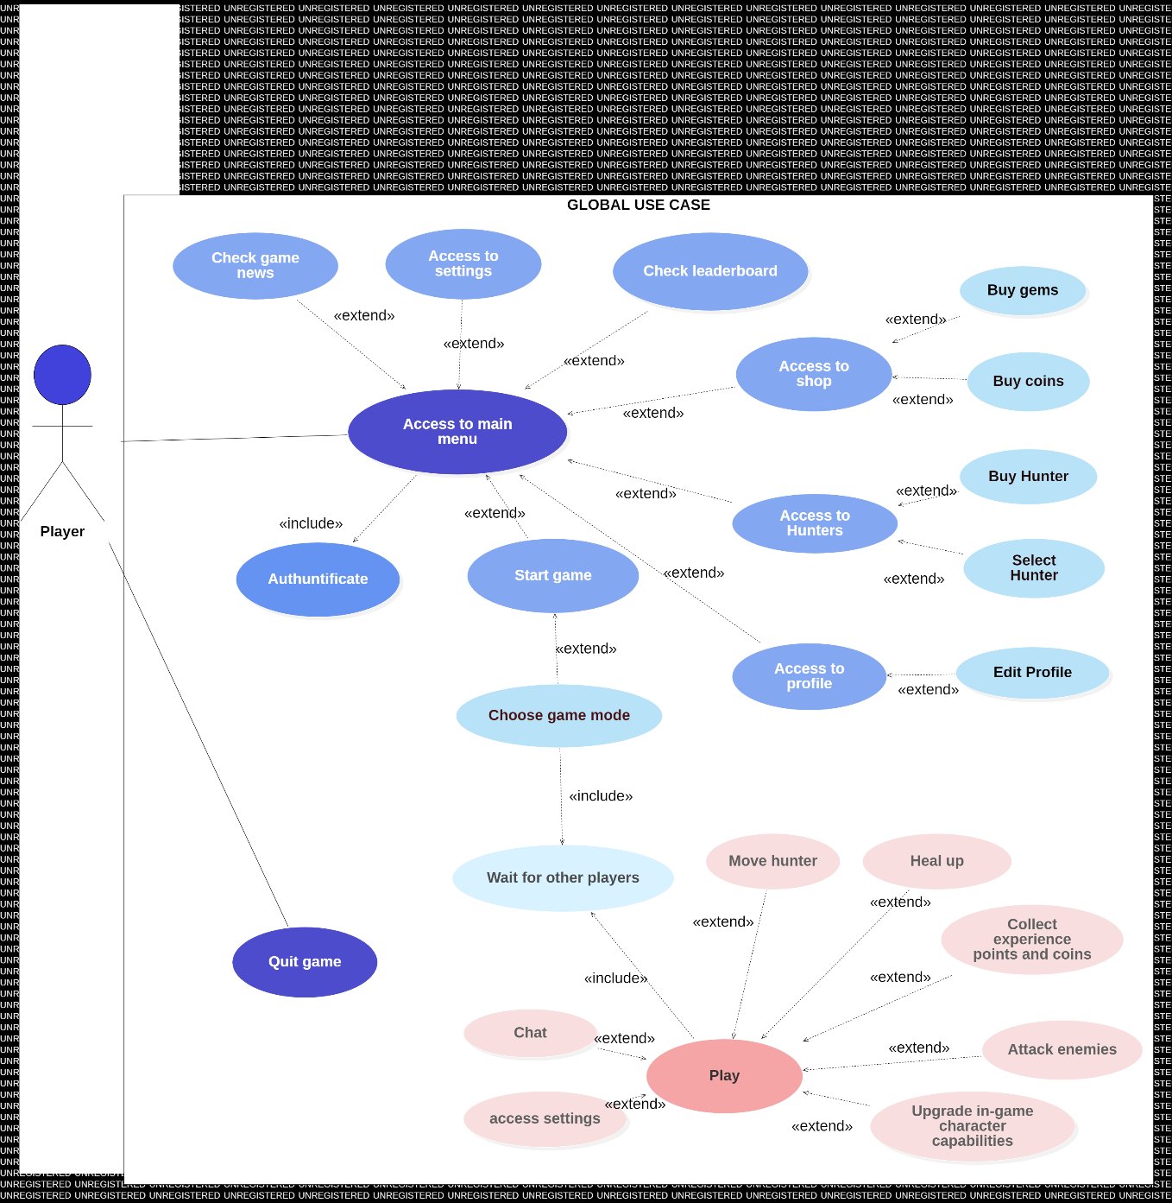

Figure 2. 1 Global Use Case Diagram

## 2.5 Activity Diagrams

“Activity diagram is another important behavioral diagram in UML diagram to describe dynamic aspects of the system. Activity diagram is essentially an advanced version of flow chart that modelling the flow from one activity to another activity.” [4]

2.5.1 Player’s Activity Diagram

The activity diagram below is the diagram that we must represent the changes that may occur over time since the player launches the game. It is considered a behavioral diagram since it describes what should happen in the modeled system and generally represents the sequence of interactions between the elements of the system and/or its actors which is in this current situation, the Player still hasn’t launched a match.

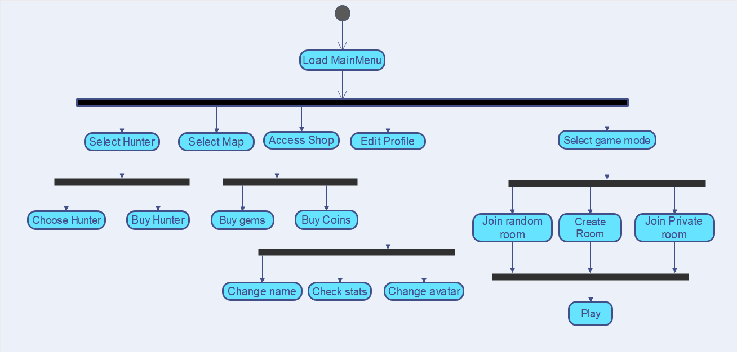

Figure 2. 2 Player's activity diagram

2.5.2 Player in-game activity diagram

Now in this section we present the activity diagram corresponding to the player’s interaction with the match flow.

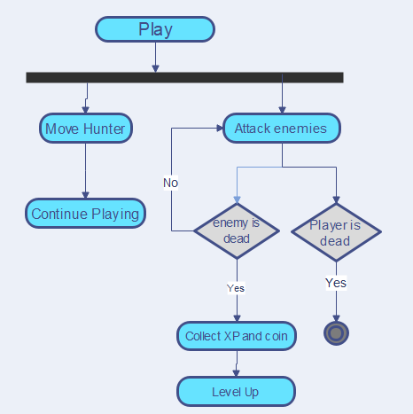

Figure 2. 3 Player in-game activity diagram

## 2.6 Class Diagrams

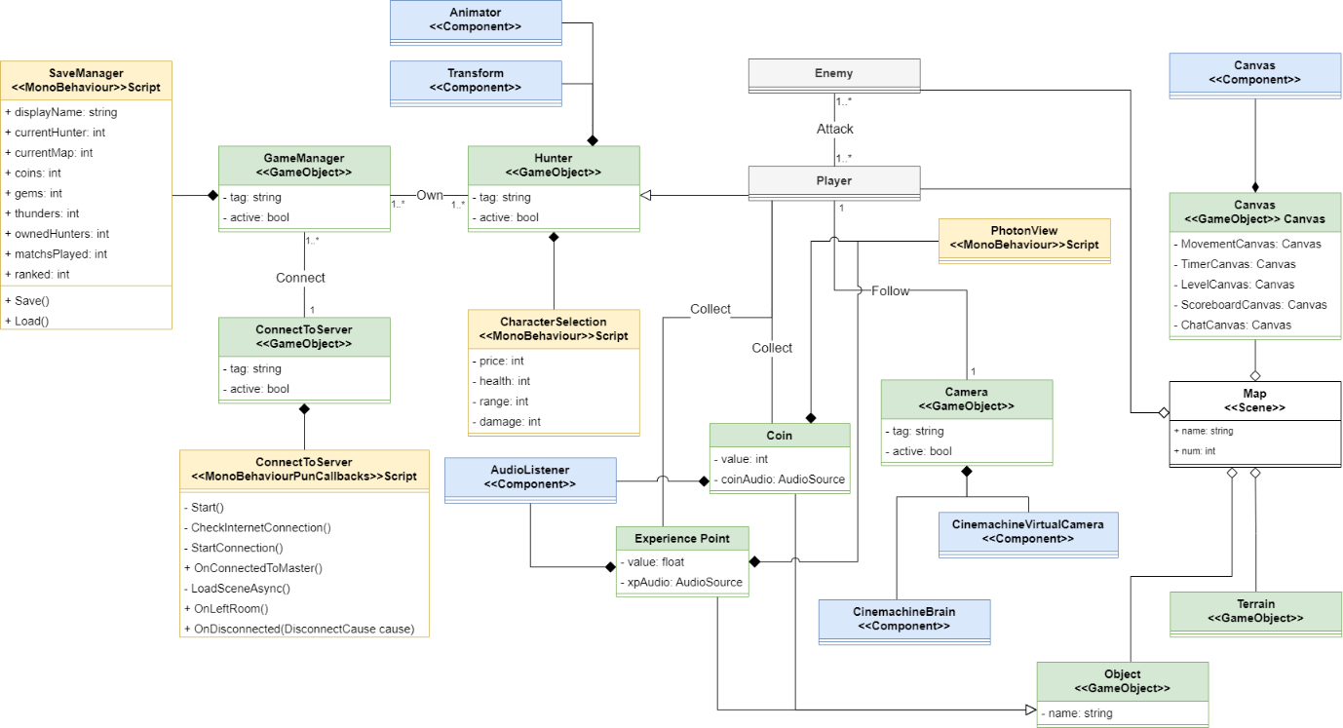2.6.1 Global Class Diagram

Figure 2. 4 Global Class Diagram

* **SaveManager** class handles saving and loading game data, while the **GameManager** class manages the game logic and coordination. The SaveManager saves and loads player progress and settings, while the GameManager controls the game flow, updates game objects, and handles player input.
* The game object **ConnectToServer** is responsible for connecting to the server with a script that establishes a connection to the game server using Photon networking. ConnectToServer works together with the GameManager utilizing the server connection script to coordinate gameplay and network operations, such as player spawning and synchronization of networked game objects.
* The relation between the **Hunter** GameObject and the **GameManager** is one of ownership or association.
* Hunter character’s GameObject uses an **animator** for animations, a **transform** for positioning, and a **HunterSelection** script for the character selection in the hunter’s panel.
* The **Player** class inherits all the associations, relationships, and attributes of the **Hunter** game object, which includes the associations with the animator, transform, and character selection script and allows the "Player" class to reuse and extend the functionality of the Hunter class.
* The **Player** can attack the **Enemy**, and the opposite can also happen.
* The "**Collect**" association indicates that the **Player** class has a relationship with both the **Coin** class and the **ExperienceCoins** class. It implies that the player can collect instances of these classes in the game and allows the Player to have methods or attributes to handle the collection of coins and experience coins.
* **PhotonView** class acts as a controller or manager that handles the synchronization and networking of the coin and experience point.
* The **AudioListener** component is responsible for receiving and processing audio in the game environment.
* The **Camera** follows the Player, and the player is followed by the Camera.
* **Coin** and **ExperiencePoint** classes and the **Object** GameObject class represents an inheritance relationship, it means that the Coin and ExperiencePoint classes inherit from the "Object”.
* The "**CinemachineBrain**" component is responsible for managing and controlling the behavior of virtual cameras in the game and handles tasks such as camera blending, target tracking, and camera transitions.
* The "**CinemachineVirtualCamera**" component represents a virtual camera in the game that defines the settings and behavior of a specific camera view, including properties like field of view, follow targets, and virtual camera effects.
* By aggregating the **CinemachineBrain** and **CinemachineVirtualCamera** components to the **Camera** game object, it means that the game object is responsible for managing and controlling these camera-related components. It allows for the coordination and configuration of virtual cameras in the game scene, providing dynamic and cinematic camera behavior.
* The **Player**, **Enemy**, **Terrain**, and **Canvas** game objects are weakly aggregated into the "**Map**" scene. Weak aggregation represents a relationship where objects are associated but not owned or managed by another object. In this case, the "Map" scene is the container or context in which these game objects exist, but it does not directly control or own them.

2.6.2 Class diagram that represents the “Player”

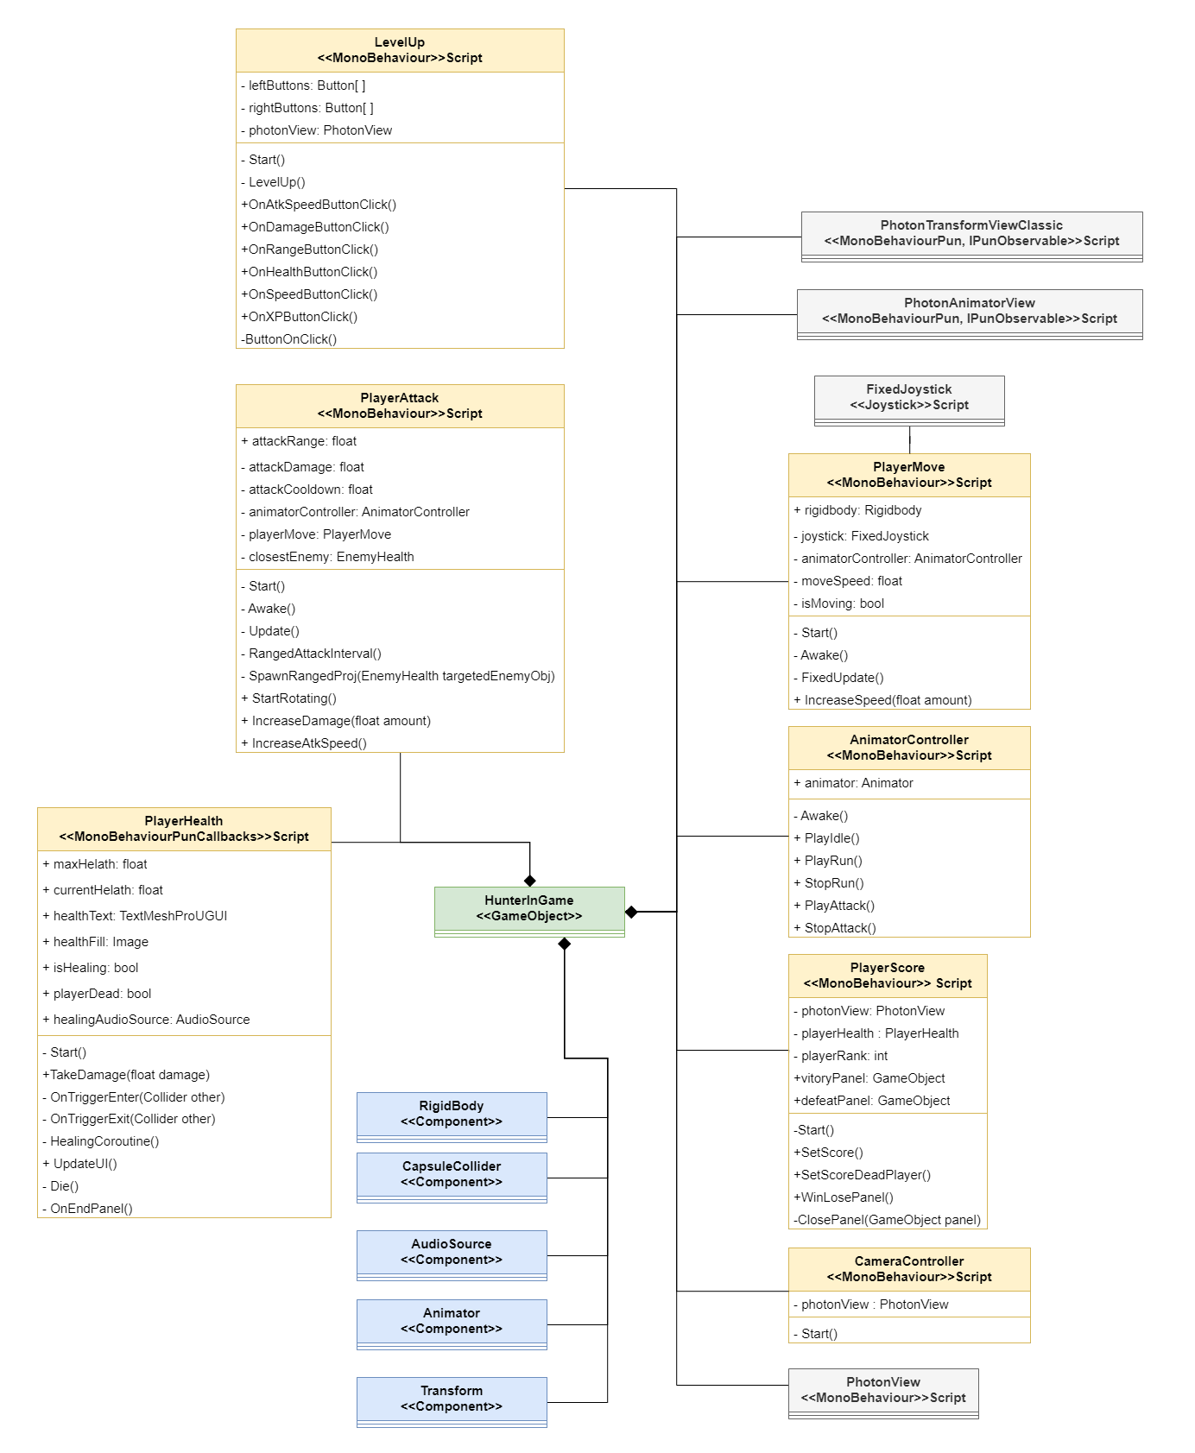

Figure 2. 5 "Player" Class Diagram

* The "**HunterInGame**" or “**Player**” is aggregated by seven scripts: "**LevelUp**," "**PlayerAttack**", "**PlayerHealth**,", "**CameraController**", ,"**PlayerScore**," "**PlayerMove**" and "**AnimatorController**".
* The "**PlayerMove**" script is responsible for moving the HunterInGame associated with a "**FixedJoystick**" class, indicating that it utilizes the input from a fixed joystick control for player movement.
* The **LevelUp** script is responsible for the leveling up during the match.
* The **PlayerAttack** script is responsible for initiating the attack.
* The **PlayerHealth** script is responsible for managing the health of the hunter in-game.
* The **PlayerScore** script is responsible for counting the score and ranking of the hunter in-game.
* The **CameraController** script is responsible for controlling the camera.
* **AnimatorController** script is responsible for controlling the animations.
* The "HunterInGame" game object in the game scene has several components associated with it, including a "**Rigidbody**," "**CapsuleCollider**," "**AudioSource**," "**Animator**," and "**Transform**." These components collectively contribute to the behavior, appearance, and interaction of the HunterInGame object within the game scene.
* The **Rigidbody** component allows for physics-based interactions and movement of the HunterInGame object in the game world and provides properties and methods to control forces, velocities, and collisions.
* The **CapsuleCollider** component defines the shape and size of the collision detection boundary around the HunterInGame object and enables collision detection with other objects in the game scene.
* The **AudioSource** component allows for playing audio clips associated with the HunterInGame object and provides methods and properties to control the playback, volume, and sound effects.
* The **Animator** component is responsible for controlling and playing animations for the HunterInGame object, since it manages the transitions between different animation states based on the game logic or user input.
* The **Transform** component represents the position, rotation, and scale of the HunterInGame object in the game world.

2.6.3 Class diagram that represents the “Enemy”

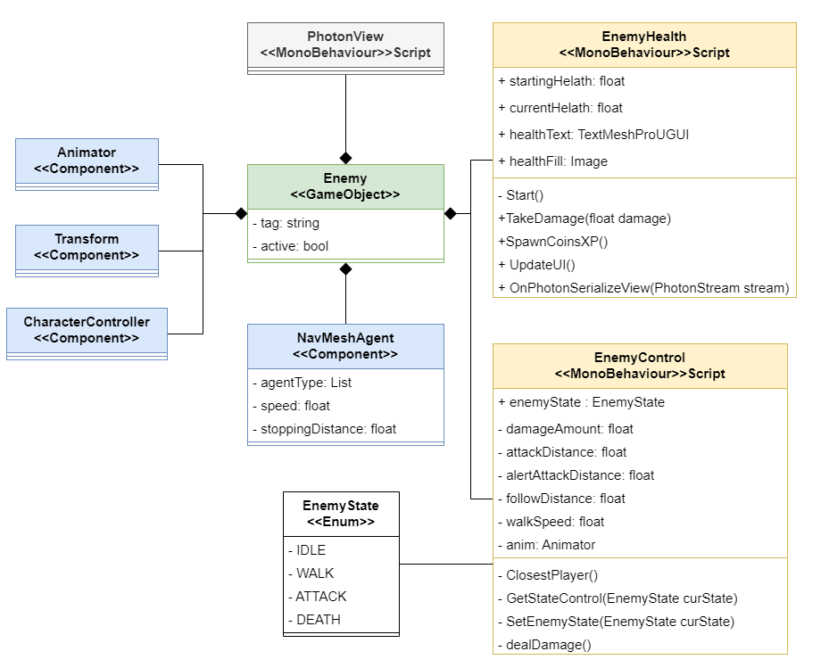

Figure 2. 6 "Enemy" Class Diagram

* The "**Enemy**" game object is aggregated by a "**PhotonView**" script and several components, including an "**Animator**," "**Transform**," "**CharacterController**," and "**NavMesh”** and as well it has two other scripts called "**EnemyHealth**" and "**EnemyControl**."
* The **PhotonView** script allows for network synchronization and communication of the Enemy game object across the players on the network.
* The **Animator** component is responsible for controlling and playing animations for the Enemy object, since it manages the transitions between different animation states based on the game logic or user input.
* The **Transform** component represents the position, rotation, and scale of the "Enemy" game object in the game world.
* The **CharacterController** component enables character movement and collision detection for the "Enemy" game object.
* The **NavMesh (Navigation mesh)** is component provides navigation functionality, allowing the **Enemy** to move along a pre-built navigation mesh in the game world.
* The **EnemyHealth** script handles health-related functionality for the Enemy, such as tracking health and managing damage.
* The **EnemyControl** script is associated with an **EnemyState** enumerator, indicating that it controls the behavior and state transitions of the Enemy based on different states defined in the enumerator.

Collectively, these components and scripts contribute to the functionality, appearance, and behavior of the "AI Enemy" in the game scene.

2.6.4 Class Diagram that represents the “Attack” use case

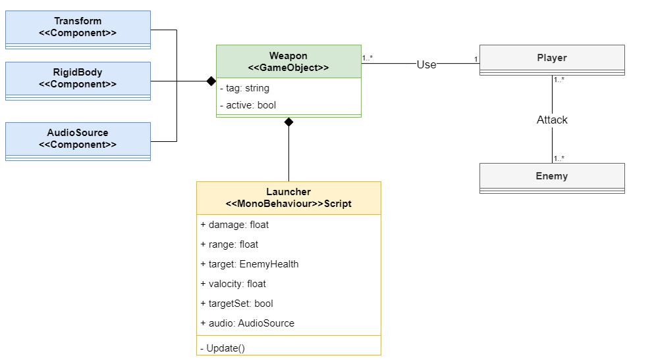

Figure 2. 7 "Attack" Class Diagram

* The **Player** uses the **Weapon** to attack the **Enemy**.
* A weapon is spawned and launched due to the **Launcher** script attached to it.
* A weapon is aggregated by **Transform**, **RigidBody**,and **AudioSource** components.
* The **Transform** is supposed to represent the position, rotation, and scale of the weapon.
* The **Rigidbody** component allows for physics-based interactions and movement of the HunterInGame object in the game world and provides properties and methods to control forces, velocities, and collisions.
* The **AudioSource** component represents an audio source within the game. It is responsible for playing audio clips and managing audio-related properties and behaviors.

2.6.5 The User Interface Class Diagram

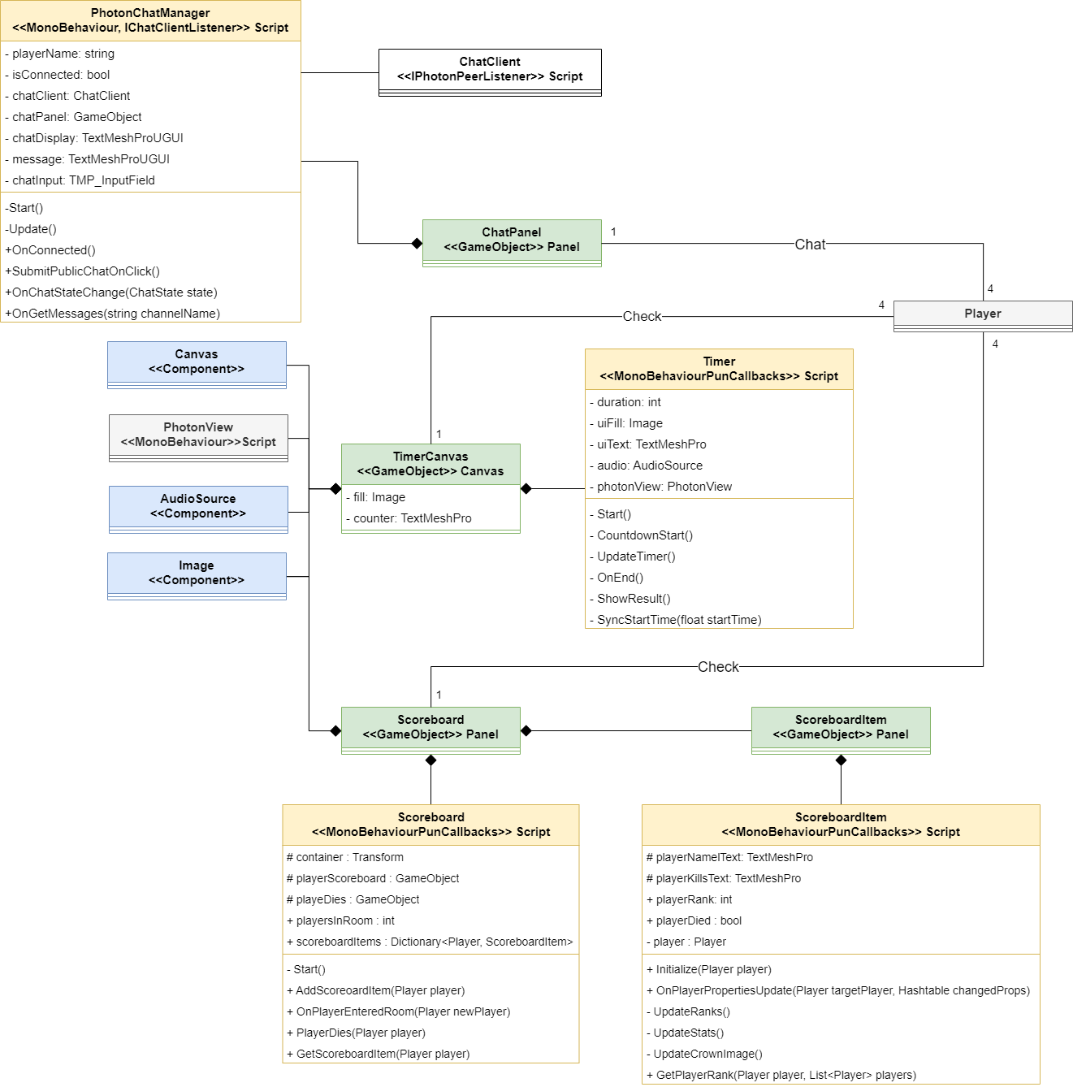

Figure 2. 8 "UI" Class Diagram

* + The **ChatPanel** is a visual component in Unity that represents the in-game chat interface between players. It is implemented as a Panel GameObject, which is a common UI element in Unity used to group and organize other UI elements.
  + The **PhotonChatManager** script is responsible for managing the chat-related operations and interactions within the game.
  + The **ChatClient** class is responsible for managing the chat functionality itself. It acts as a client that connects to the chat server, sends, and receives chat messages, and handles other chat-related operations.
  + The **ScoreboardPanel** is a Panel GameObject that serves as the container for the scoreboard UI. It acts as a parent object that organizes and displays the individual scoreboard items.
  + The **ScoreboardItemPanel** represents an individual item within the scoreboard and displays information such as the player's nickname, their kills, and a crown image if they are in the first rank.
  + The **ScoreboardItem** script is responsible for managing and updating the player’s information. • The **TimerPanel** provides a visual representation of the time remaining to all players in a synchronized manner.

**Chapter 3**

# Development

## 3.1 Work Environment

This section covers the selection of hardware, software and technical tools that carried out this whole project.

3.1.1 Hardware Environment

To carry out our project, we used our personal laptops and smartphones with the configuration in table 3.1:

Table 3. 1 Hardware Environments

|  |  |  |  |  |
| --- | --- | --- | --- | --- |
| **Name** | **RAM** | **CPU** | **GPU** | **Screen** |
| Laptop  DELL G-15 5511 | 32Go | 11th Gen Intel™  I5-11400H @2.70GHz | NVIDIA GeForce RTX3050 | 15.6"  FHD 120Hz |
| Smartphone  REDMI Note 10S | 8Go | Octa-core (2x2.05 GHz Cortex-A76 & 6x2.0 GHz Cortex-A55) | Mali-G76 MC4 | 6.3" |
| Laptop  HP-Pavillion Gaming | 12Go | 8th Gen Intel™  I5-8300H | NVIDIA GeForce  GTX1050 | 15.6"  FHD 120Hz |
| Smartphone Xiaomi Redmi Note 8 | 4Go | Octa-core (4x2.0 GHz Kryo 260 Gold & 4x1.8 GHz Kryo 260 Silver) | Adreno 610 | 6.3” |

3.3.2 Software Environment

* **Unity:**

“Unity is a cross-platform game engine developed by Unity Technologies, first announced, and released in June 2005 at Apple Worldwide Developers Conference as a Mac OS X game engine. The engine has since been gradually extended to support a variety of desktop, mobile, console and virtual reality platforms.”[5]

Figure 3. 1 Unity logo

* **Visual Studio:**

“Visual Studio is an integrated development environment from Microsoft. It is used to develop computer programs including websites, web apps, web services and mobile apps. It supports multiple languages such as C#, C++, Java Script, Python, etc.” 6]

Figure 3. 2 Visual Studio logo

* **Blender:**

“Blender is a free and open-source 3D computer graphics software tool set used for creating animated films, visual effects, art, 3D-printed models, motion graphics, interactive 3D applications, virtual reality, and, formerly, video games.”[7]

Figure 3. 3 Blender logo

* **Mixamo:**

“Mixamo is a 3D computer graphics technology company. Based in San Francisco, the company develops and sells web-based services for 3D character animation. Mixamo's technologies use machine learning methods to automate the steps of the character animation process, including 3D modeling to rigging and 3D animation.”[8]

Figure 3. 4 Mixamo logo

* **Diagrams.net**

****Diagrams is an open-source online application for creating diagrams, an easy-to-use tool that offers many features such as real-time collaborative editing, online storage on Google Drive or One Drive, and export to PNG, JPG, SVG formats.[9]

Figure 3. 5 Diagrams logo

* **Photoshop :**

“Photoshop is an image creation, graphic design and photo editing software developed by Adobe. The software provides many image editing features for pixel-based images, raster graphics and vector graphics.**”**[10]

Figure 3. 6 Photoshop logo

3.3.3 Platforms and Libraries

**PlayFab:**

“PlayFab is a complete backend platform for live games with managed game services, real-time analytics, and LiveOps. These features can help you boost your revenue and increase player engagement while cutting costs. This topic provides a high-level overview of the PlayFab features.”[11]

Figure 3. 7 PlayFab logo

**Photon Fusion Networking SDK :**

Fusion is a new high performance state synchronization networking library for Unity. With a single API, it supports two fundamentally different network topologies as well as a single player mode with no network connection. It is built with simplicity in mind to integrate naturally into the common Unity workflow, while also offering advanced features.[12]

Figure 3. 8 Photon logo

3.3.4 Programming and modeling languages

* **C Sharp:**

C# is a general-purpose high-level programming language supporting multiple paradigms. C# encompasses static typing, strong typing, lexically scoped, imperative, declarative, functional, generic, object-oriented, and component-oriented programming disciplines.[13]

Figure 3. 9

C# logo

* **UML**

The Unified Modeling Language is a general-purpose, developmental modeling language in the field of software engineering that is intended to provide a standard way to visualize the design of a system.[14]

Figure 3. 10 UML Logo

## 3.2 Timeline

The “Table 3.2” below represents the planning timeline of the workflow that we undertook during the internship period.

Table 3. 2 Timeline table

|  |  |  |  |  |  |  |  |  |  |  |  |  |  |  |  |  |
| --- | --- | --- | --- | --- | --- | --- | --- | --- | --- | --- | --- | --- | --- | --- | --- | --- |
| Weeks  Phase  (Sprint) | February | | Mars | | | | April | | | | May | | | | June | |
| **3** | **4** | **1** | **2** | **3** | **4** | **1** | **2** | **3** | **4** | **1** | **2** | **3** | **4** | **1** |
| Preliminary Study | X | X |  |  |  |  |  |  |  |  |  |  |  |  |  |
| 3D Modeling |  |  | X | X | X | X | X |  |  |  |  |  |  |  |  |
| UI Design |  |  |  |  | X | X | X | X |  |  |  |  |  |  |  |
| Programming & Controls |  |  |  |  |  | X | X | X | X | X | X | X |  |  |  |
| Game enhancement & Deployment |  |  |  |  |  |  |  |  |  |  |  | X | X | X | X |

During the development process of the video game, we cited several key phases that matches with the sprints that we organized, and these phases included:

• **Preliminary Study**: This phase involved researching the target market, user preferences, and industry trends to inform our game's design and development.

• **3D Modelling & UI Design:** With the game's design established, we moved onto creating 3D models of the game's characters, environments, and other assets and user interfaces.

**• Programming & Controls**: This phase or sprint involved coding the game's mechanics, features, using C# and Photon programming languages and tools.

• **Game enhancement & Deployment**: Finally, we tested the game to ensure that it is stable, enjoyable, and met our quality standards and it included both internal testing and feedbacks from friends who tested the game.

Each of these phases required significant effort and expertise and played a crucial role in bringing our game to life.

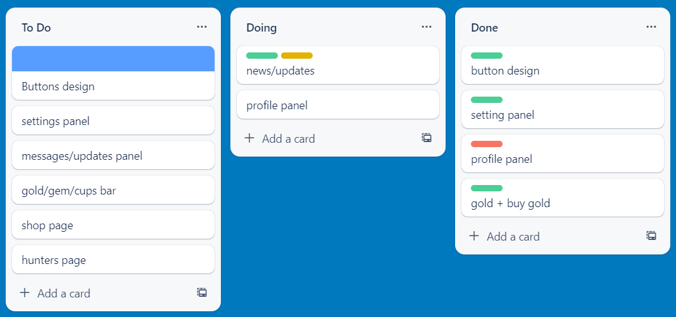To easily plan our work and task distribution through Scrum, we used the project management platform Trello.com so that we can manage our tasks among team members and Trello made us able to create and organize the project tasks into boards, lists, and cards.

Figure 3. UI design schedule on Trello

## 3.3 Sprint Development Process

The development process follows the Scrum methodology where each sprint focuses on delivering a working and usable version of the game and at the end of every, after being iterated and reviewed by the scrum master, the sprint is conducted to demonstrate the completed work and gather feedbacks which is used to inform future sprints and to adjust any necessary adjustments to the development process.

Starting from here, we will present a well-detailed report of the sprints that we developed and done during the past three months.

### 3.3.1 Sprint 1: “3D Modelling”

#### 3.3.1.1 Enhancing Player Experience

Before digging deeper into the 3D Modelling & Design and since this section doesn’t actually require a detailed conception we invested some time in making a research about the effective utilization of colors, sounds and their impact on the player’s experience and behavior during the game since there’s a live chat and we want no hate or Linguistic violence to be tolerated when playing, So colors, sounds and shapes will trigger the player to have a cool and calming experience.

* + **Behaviorism** : or also known as behavioral psychology, is a theory of learning that states “all behaviors are learned through the interaction with the environment” following a process called conditioning, which means that in our situation, the player’s behavior will be a response to what he’s experiencing during the game and that’s why we as developers and designers will have to ensure a fluent and calming experience.
  + **Color psychology in game design** : after some research that we made on the net, we knew that it has been scientifically proven that colors will certainly shape the player’s behavior, since it affects the nervous system and controls the player’s attention.
  + **Monochromatism** : is a palette that consists of different shades of the same color, and it plays a big role in enhancing a particular mood or to create a point of focus.



Figure 3. Monochromatism Colour Palette

#### 3.3.1.2 Development of Sprint 1

**3D Modelling**

3D modeling is the process of creating 3D objects on a computer using modeling software. The term “3D modeling” refers to this entire process, or in other words, the creation of 3D models.

The creation of a 3D object passes through a long process which we’ll describe later throughout this section, because before passing through that we need to choose the modelling software that we’ll work on when knowing that nowadays there’s multiple modelling software programs.

After making some research we decided to use “Blender” since it’s an open-source software that has many advantages for modelling, such as:

* It supports a variety of modelling tools and techniques, such as sculpting, retopology, modifiers, curves, etc.
* It has a powerful UV mapping system that allows you to unwrap your mesh and paint textures directly onto it.
* It has a node-based material system that lets you create realistic and complex materials for your models.
* It has a built-in rendering engine called Cycles that can produce high-quality images and animations.

Once the Modelling environment is set, we must go through a process that includes these phases mentioned below.

##### 3.3.1.2.1 Conceptualization

This phase involves brainstorming and thinking about a clear idea of the 3D object that we want to create and once the idea is clear and sharp, we start sketching, gathering references, and planning the overall design of our model.

We planned to create two maps, and three game characters which we decided to call “Hunters”.

We started by thinking about the maps which will be two different worlds, a city environment and the other one is based on a fantasy-looking countryside environment.

Before starting to sketch and model we gathered references from real world objects and through observing different Low-Poly maps from different games, until we came up with the idea of dividing each map into four blocks where each block has its own vibe and so that the players can fluently move around and memorize the maps.

Then, we started to think about making the characters in relation to the maps that we made, and that went smoothly until we ended up with three hunters’ ideas which are a modern looking swordsman, an archery girl, and a grenade thrower.

##### 3.3.1.2.2 Modeling

Modeling is the creation of a three-dimensional object by adding, subtracting, and modifying its components using Blender. There are several types of modeling, such as:

* Curve modeling.
* Surface subdivision modeling.
* Implicit surface modeling.
* Geometry-based modeling.
* Volumetric modeling.
* Parametric modeling.
* Polygonal modeling.

Modeling is the first step of creating every 3D object, in which we create the basic structure and shape of the destined 3D object, and it is called a “Mesh”.

A mesh is created by manipulating vertices, edges, faces and adding modifiers, also it includes creating primitive shapes, extruding, scaling, and adding details to refine the model.

To make our game characters, we used the polygonal type and a "High Poly" modeling method, which means that 3D models have many polygons, resulting in smooth and highly detailed models. We also utilized "Low-Poly" modeling, a technique that involves using a reduced number of polygons, for modeling the maps. This was achieved with the help of various modifiers such as skin modifier, subdivision surfaces and auto-mirror.

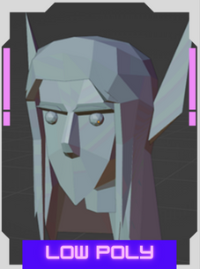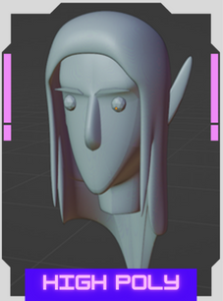

Figure 3. 13 Low Poly and High Poly

Through the "High Poly" technique, we shape the hunter’s virtual existence, infusing them with realism and visual allure and through the artistry of "Low-Poly" modeling, we optimize the number of polygons, finding the perfect balance between performance and aesthetics.

To create the High Poly Hunters, we used some techniques that we state right away:

**The Skin modifier** enabled us to create basic humanoid shapes starting from a single vert and initializing it as the root of the object by defining an initial structure and then gradually adding thickness and volume to it.

**The Subdivision Surface** **modifier** also played an important role in achieving smoothness and increasing the level of detail in the models. This modifier subdivided the surfaces of the models, resulting in a higher density of polygons and a more refined appearance.

**The Mirror modifier** allowed us to create one half of a model and automatically mirror it to the other side, without the need for manual duplication and adjustment.

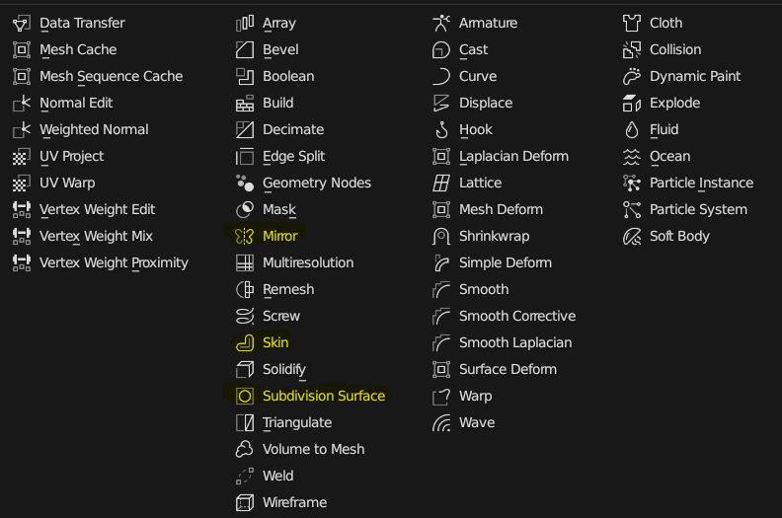

Figure 3. 14 Modifiers used to create 3D models

The modelling phase of the characters takes some time and effort until we end up with a mesh like the figures down below.

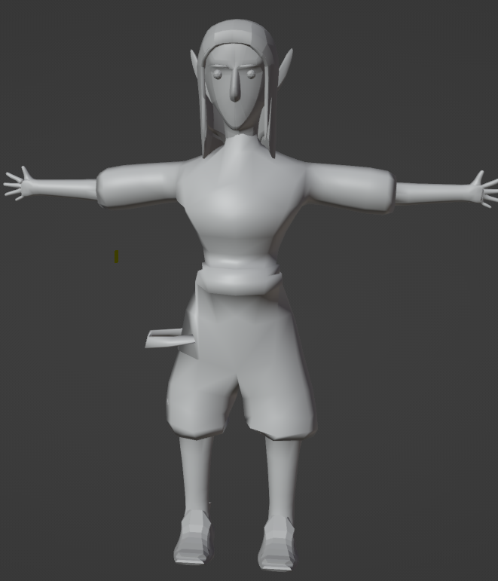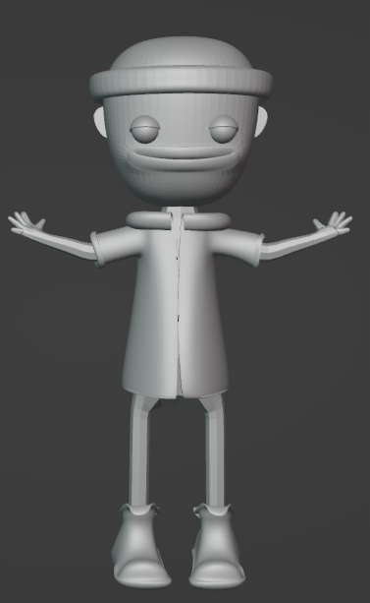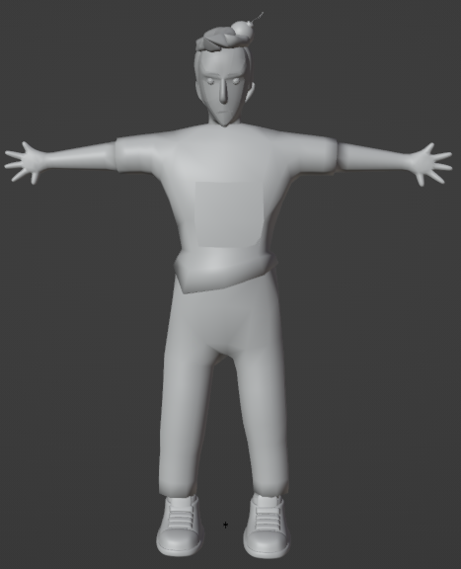

Figure 3. 15 Base Mesh of the characters

As for the maps, we created a plane base for each map and divided it into 4 blocks and a center meeting point and we then proceeded to create individual objects that would populate the maps using various low-poly modeling techniques such as vertex manipulation, extrusion, and scaling to refine each model while strategically limiting the number of polygons until we were able to maintain the low-poly style while ensuring a visual appeal.

Once the objects were created, we seamlessly integrated them into Unity 3D and carefully positioned and arranged each subject within the map, paying attention to scale, placement, and overall composition to create an immersive and cohesive environment.

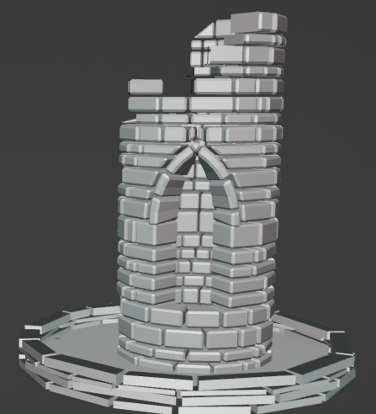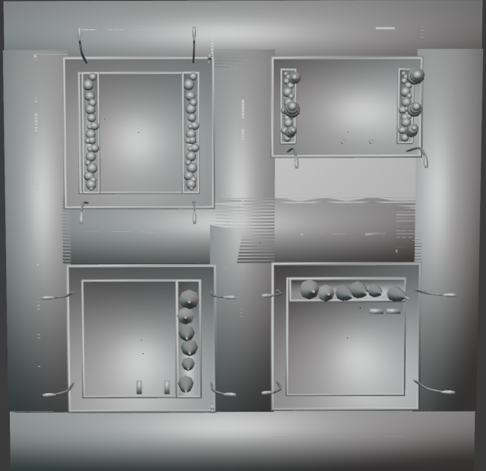

Figure 3. 16 Map & 3D object base mesh.

Finally, when the modeling phase is confirmed, and the base mesh is ready, comes the time for the **UV mapping**.

##### 3.3.1.2.3 UV Mapping

UV mapping involves the process of unwrapping the surface of a 3D model onto a 2D plane, creating a flattened representation of the model's geometry. This allows us to apply textures and images onto the model accurately and precisely by manipulating and arranging the UV coordinates so we can ensure that the textures align correctly with the model's surfaces.

We utilized UV mapping tools within Blender, which provided us with techniques to easily unwrap our models and optimize texture utilization.

With well-executed UV mapping, we will be able to enhance the visual quality of our models by applying **textures**.

##### 3.3.1.2.4 Texturing

Texturing is an elementary aspect of 3D modelling and game development that involves applying surface materials, colors, and patterns to the 3D models to enhance their visual appearance and realism. In our project, we invested significant time and effort into the texturing phase.

The texturing process went through the following steps:

* **Texture Creation**: In the texture creation process, we utilized Photoshop to create an 8-bit color palette which contained a limited set of colors to be used in our textures.



Figure 3. 17 8bit Colour Palette

* **Texture Mapping**: Once the textures were created, we utilized UV mapping coordinates obtained during the UV mapping phase to accurately apply the textures to the corresponding areas of the 3D models.
* **Material Creation**: We assigned materials to different parts of the models and defined their visual properties such as color, shininess, reflectivity, and transparency.

This step involved configuring material parameters and adding an Image Texturing which means that the mesh will be colored by that image until it is cleaned up and refined in the texture mapping technique.

As an example, to texture the shoes in the figure 3.19, we created and applied the material as show in the figure 3.18 to it:

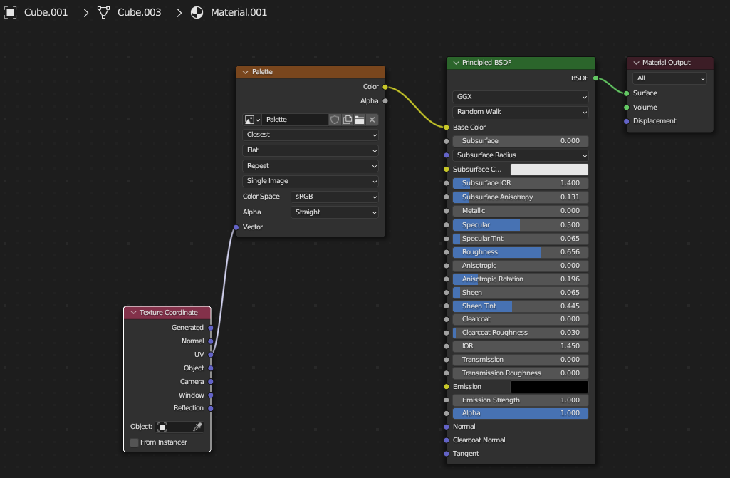

Figure 3. 18 Material Creation

* **Texture Mapping Techniques**: To enhance the realism of our texturing we went through the UV editing process where we select a group of polygons (faces) and change their color according to the palette that we are using.

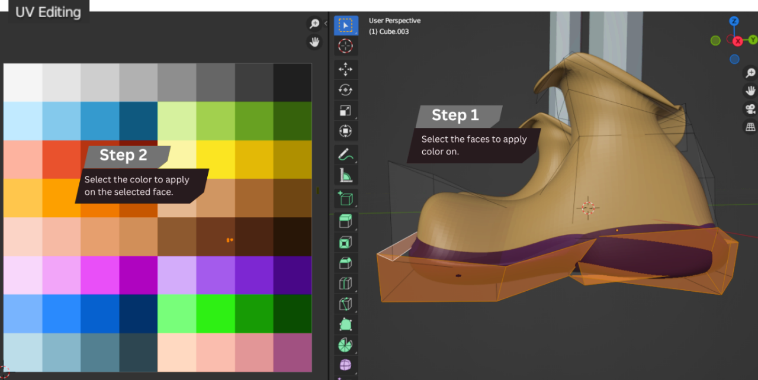

Figure 3. 19 Texture Mapping

##### 3.3.1.2.5 Rigging

Rigging is an essential step in character animation as it enables the model to be posed and animated and it is the process of creating a digital skeleton known as a rig which is a structure of bones and joints that imitate the movement and flexibility of a real-life skeleton.

To rig our characters, we utilized [Mixamo.com](https://www.mixamo.com/#/) which is an online platform that provides an automated rigging and animation service accompanied by a library of pre-built rigs and animations that can be easily applied to 3D models.

Once the model is uploaded, Mixamo automatically analyses the geometry and applies a skeleton (rig) to the character including limbs, spine, and head.

This rigging process saved us time and effort compared to manually creating a rig from scratch.

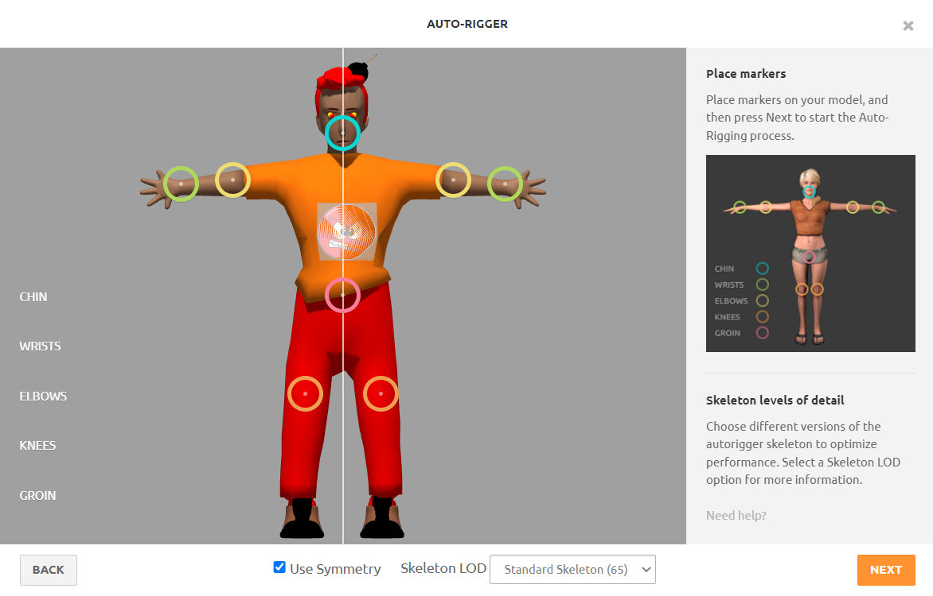

Figure 3. 20 Character Rigging in Mixamo

By utilizing Mixamo for rigging, we were able to create functional skeletons quickly and for our characters. This allowed us to focus more on animating the characters and bringing them to life in our game.

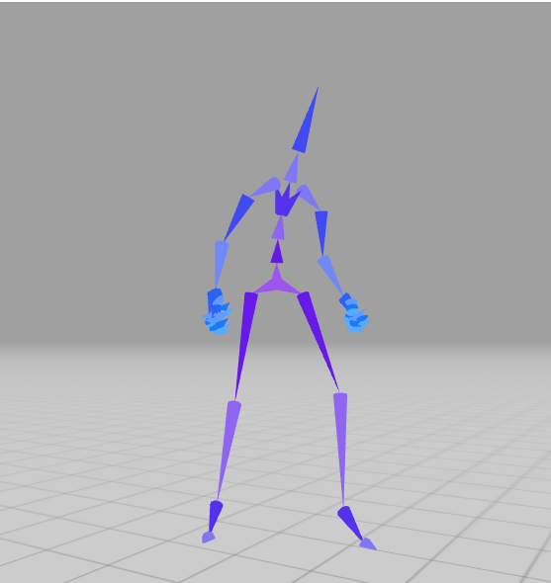

Figure 3. 21 The skeleton of the character

Finally, after modeming, texturing, and rigging our hunters we ended up having this:

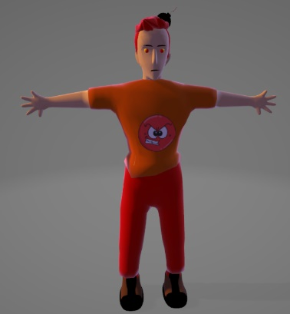

Figure 3. 22 Final rendered and rigged character

and as for the maps we organized the 3D objects in Unity to finally end up with these two maps:

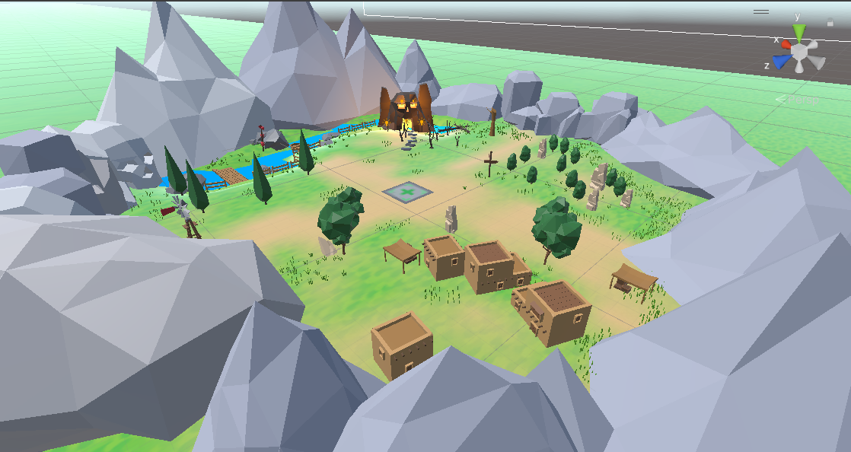

Figure 3. 23 Nature Map

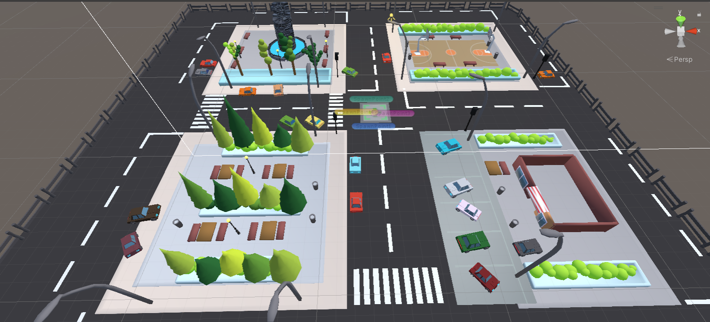

Figure 3. 24 City Map

**Game scenes:**

Now, we will showcase the game scenes that we have created during the duration of our internship.

**Terrain:**

Unity provides a range of tools for creating environmental features such as terrains and vegetation. Our terrain spans one square kilometer and includes both rural and urban areas.

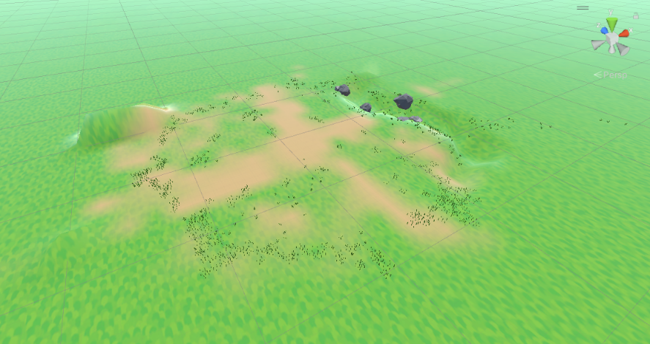

Figure 3. 25 Map Terrain

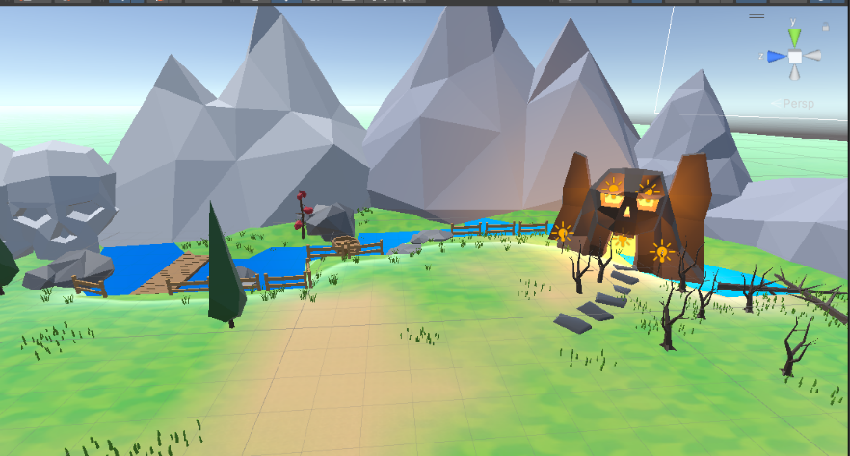

Figure 3. 26 Finalized Map example 1

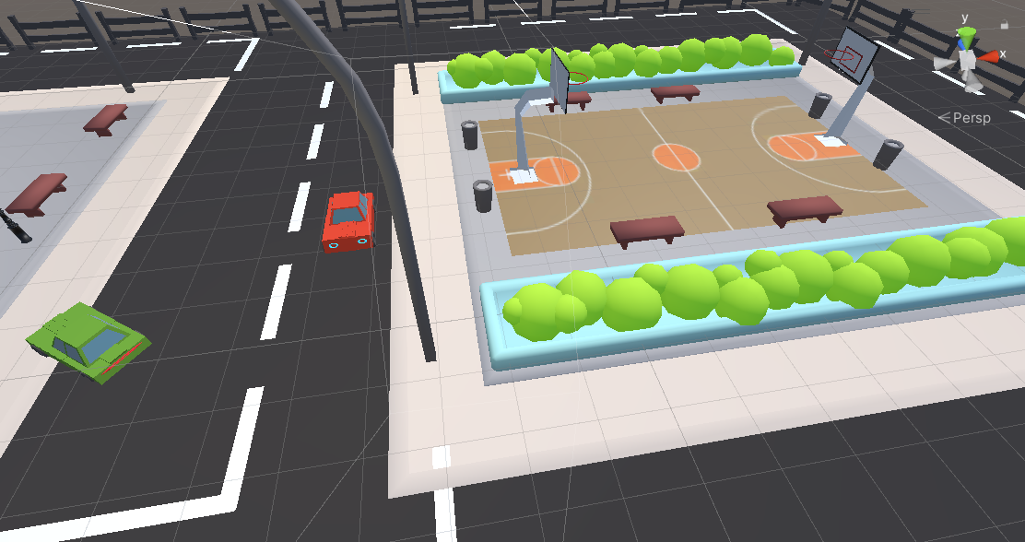

Figure 3. 27 Finalized Map example 2

### 3.3.2 Sprint 2 “UI Design”

UI design is also an important step in our game, allowing players to quickly understand how to interact with the game and creating a smooth experience where the UI elements feel like a natural part of the game world, rather than non-organized overlays.

Looping through this phase of the game design process, using photoshop, we tried our best to create cool looking buttons and panels, and through programming we created responsive controls that makes the player feel connected to the game world and its mechanics by implementing common UI patterns and elements, minimizing unnecessary steps, providing intuitive controls, and optimizing interactions, so the players can quickly understand and interact with the interface and focus more on the game itself, rather than struggling with the interface.

#### 3.3.2.1 User-centered Design?

While designing the desired UI for our game, we asked ourselves “Who’s our target players?” and by thinking about that we took a user-centered approach by keeping our players in mind every step of the way, and to make sure that our UI resonates with our target audience, we actively involved them in the design process by making our friends testing and giving feedbacks throughout the game design cycle.

The feedbacks we received from our friends was incredibly valuable as it guided our design decisions and helped us understand their expectations, preferences, and weakness points and following that we listened to their suggestions and incorporated their ideas into the UI design to ensure that it met their needs and aligned with their gaming habits.

#### 3.3.2.2 Detailed conception of the sprint 2

Following what we mentioned before in the functional requirements and the sprint backlog, we carefully created UML diagrams to clarify each functionality.

##### 3.3.2.2.1 Use case diagrams of the sprint 2

Figure 3.28 states the use case diagram of sprint 2.

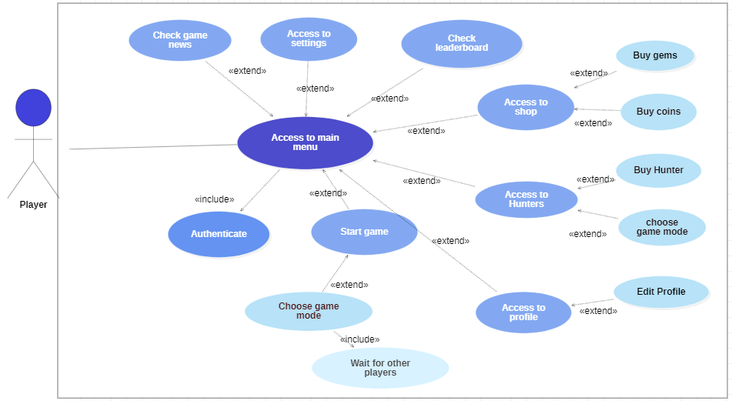

Figure 3. 28 Sprint 2 use case diagram

**Refinement of the "Authenticate" use case**

Authentication mechanisms present several challenges, as they are difficult to secure due to the expensive security and authentication systems.

Additionally, PlayFab presents features such as player authentication, data validation, and server-side logic to help prevent cheating, unauthorized modifications, and other security threats within our game and that’s why with PlayFab implemented, users will be automatically authenticated upon launching the game after being once registered and logged in.

Figure 3.29 shows the use case diagram for the use case "Authentication."

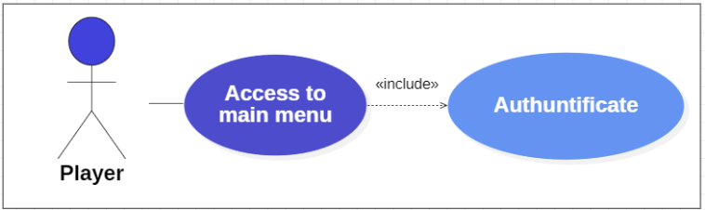

Figure 3. 29 Authenticate use case diagram

Table 3.3 shows the refinement of the "Authentication" use case.

Table 3. 3 "Authenticate' Description table

|  |  |
| --- | --- |
| **Title** | Authenticate |
| **Actors** | Player |
| **Goal** | verify the identity of the player and grant access to the game. |
| **Precondition** | The player is registered in PlayFab’s database and has a valid username and password. |
| **Post-condition** | The player is successfully authenticated and gains access to the main menu. |
| **Main scenario** | 1. The player launches “Let’s Hunt”. 2. The game presents the player with the login form. 3. The player enters their email and password. 4. The player submits the login form. 5. The GameClient verifies the entered credentials against the stored user data. 6. The player is signed in. |
| **Alternative scenario** | 3.a - The player enters missing or wrong information:   * The player is asked to refill the form with the right inputs. * The scenario continues from step 4.   2.a - The player doesn’t have an account:   * The system informs the player that there’s no data according to what he inputs. * The player clicks on the register button. * The player fills and submits the register form. * An email is sent to the entered email. * The player receives the verification email and is asked to verify his account. * The player’s account is now verified. * The scenario resumes from step 2. |

**Refinement of the "Access main menu" use case**

The player accesses the main menu after being authenticated.

This menu grants him the options to check updates notifications of the day or leaderboard, adjust the settings, access the hunters panel, visit the shop panel, view the profile panel, and explore the start match menu.

Figure 3.30 shows the use case diagram for the use case "Access the main menu".

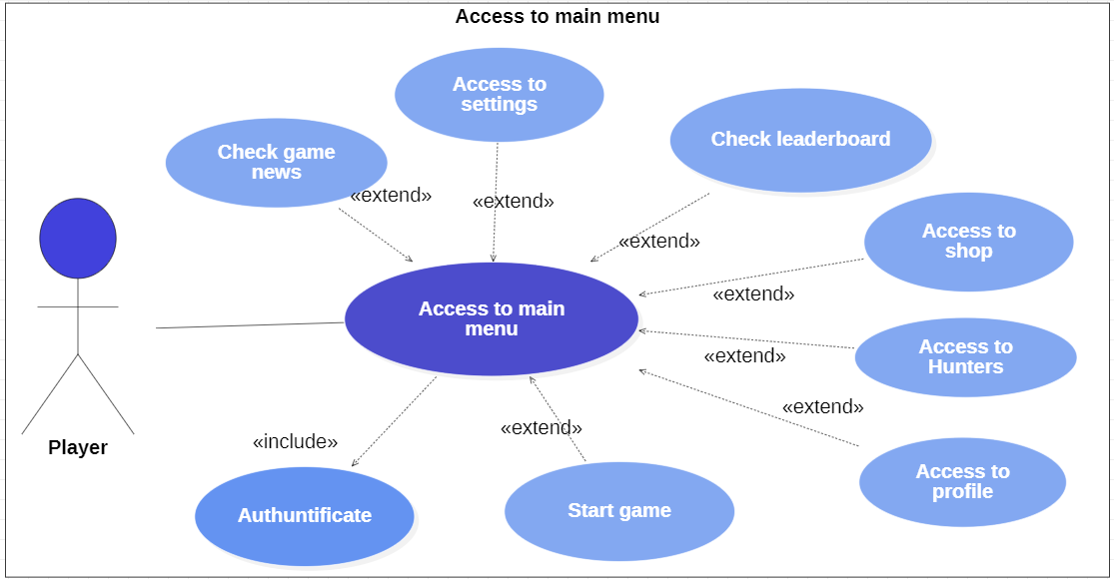The table 3.4 below shows the refinement of the " Access to Main menu " use case.

Figure 3. 30 "Access to main menu" use case diagram

Table 3. 4 "Access to main menu' Description table

|  |  |
| --- | --- |
| **Title** | Access Main menu |
| **Actors** | Player |
| **Goal** | Allow the player to access the main menu interface and navigate through its panels for various actions and interactions. |
| **Precondition** | The game is running, and the player is signed in via PlayFab. |
| **Post-condition** | The player successfully accesses the main menu and can interact with its panels, including the Hunters Panel, Shop Panel, Profile Panel, and Matchmaking Panel. |
| **Description of the main scenario** | 1. 1- The player starts the game and is signed in. 2. The main menu is loaded and displayed on the screen. 3. The main menu interface includes several panels, such as:  * Hunters Shop and Selection: The player can browse and select hunters to purchase. * Shop Panel: The player can buy coins or gems using the in-game currency. * Profile Panel: The player can change their name and avatar, as well as check their game stats. * Matchmaking Panel: The player can initiate the process of joining or hosting a match.  1. The player can navigate through the main menu. |
| **Description of alternative scenario** | 1.a. The player encounters a network connection issue:   * When the player starts the game and attempts to access the main menu, a network connection issue occurs. * The game displays an error message indicating the network connection problem. * The player is prompted to check their internet connection and retry accessing the main menu. * The scenario continues from step 2. |

**Refinement of the "Select map" use case**

After loading the main menu, the player has the option to choose between two maps.

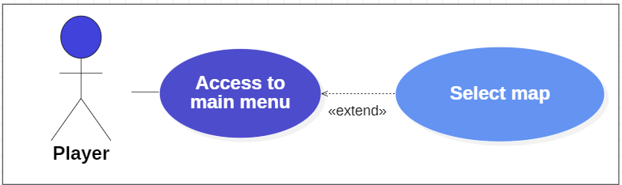Figure 3.31 shows the use case diagram for the use case "Select map".

Figure 3. 31 Select map sue case diagram.

The table 3.5 below shows the refinement of the " Select map " use case.

Table 3. 5 "Select map" Description table

|  |  |
| --- | --- |
| **Title** | Select map |
| **Actors** | Player |
| **Goal** | Allow the player to select a map for gameplay. |
| **Precondition** | The game is running, and the player has accessed the main menu. |
| **Post-condition** | The player successfully selects a map for gameplay. |
| **Description of the main scenario** | 1. The player is in the main menu and decides to select a map for gameplay. 2. The player navigates to the map selection option or panel. 3. The game displays a list of available maps for selection, along with relevant information such as map name, description, and difficulty level. 4. The player can browse through the list of maps by sliding his finger right and left. 5. The player selects a desired map by clicking on it. 6. The game highlights the selected map to indicate the choice. |

**Refinement of the "Check message of the day" use case**

Each day a notification will be sent to the player, and the player can either check it from the notch bar or by clicking on the newsletter button.

Figure 3.32 shows the use case diagram for the use case "Check message of the day".

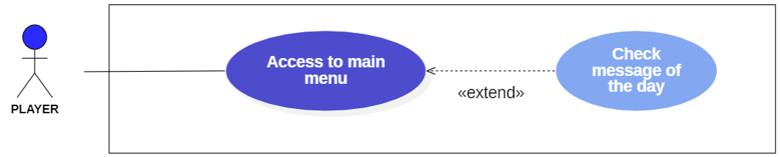

Figure 3. 32 Check message of the day use case diagram

The table 3.6 below shows the refinement of the " Check message of the day" use case.

Table 3. "Check message of the day" Description table

|  |  |
| --- | --- |
| **Title** | Check message of the day |
| **Actors** | Player |
| **Goal** | Allow the player to access and check the daily message/notification within the game. |
| **Precondition** | The game is running, and the player has accessed the main menu. |
| **Post-condition** | The player successfully checks the daily message of the day. |
| **Description of the main scenario** | 1. The player receives a notification indicating the arrival of the daily message. 2. The player clicks on the notification. 3. The game is launched. 4. The player clicks on the newsletter button. 5. The player reads the message of the day. |
| **Description of alternative scenario** | 2.a If the player misses the initial notification:   * The player can start the scenario from step 3. |

**Refinement of the "Access settings" use case**

Like every other game in the world, our game has its own SFX, music and graphics, which the player can adjust and control through the settings panel.

Figure 3.33 shows the use case diagram for the use case "Access settings".

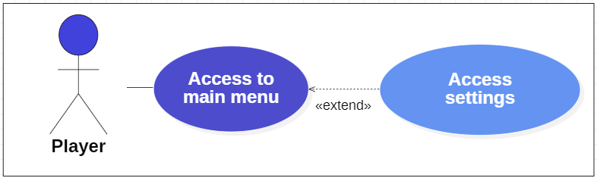

Figure 3. 33 Access to settings use case diagram

The table 3.7 below shows the refinement of the "Access Settings" use case.

Table 3. 7 "Access to settings" Description table

|  |  |
| --- | --- |
| **Title** | Access settings |
| **Actors** | Player |
| **Goal** | Allow the player to access and adjust the game's SFX, music, and graphics settings through the settings panel. |
| **Precondition** | The game is running, and the player has accessed the main menu. |
| **Post-condition** | The player successfully accesses and adjusts the SFX, music, and graphics settings according to their preferences. |
| **Description of the main scenario** | 1. The player is in the main menu and decides to adjust the game's settings. 2. The player navigates to the settings option or panel within the game interface. 3. The game displays the settings panel, which includes options to adjust SFX, music through sliding a slider bar, and adjust the graphics through a dropdown. |

**Refinement of the "Access to Hunters" use case**

The player can access the Hunters panel to select or buy a hunter.

Figure 3.34 shows the use case diagram for the use case "Access to Hunters".

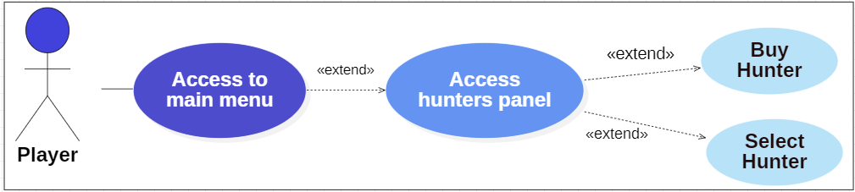

Figure 3. 34 Access to hunters panel use case diagram

Table 3.8 below shows the refinement of the "Access to Hunters" use case.

Table 3. 8 "Access to hunters" Description table

|  |  |
| --- | --- |
| **Title** | Access to Hunters |
| **Actors** | Player |
| **Goal** | Allow the player to access the Hunters panel and perform actions such as selecting or buying a hunter. |
| **Precondition** | The game is running, and the player has accessed the main menu. |
| **Post-condition** | The player successfully accesses the Hunters panel and can select or buy a hunter. |
| **Description of the main scenario** | 1. The player is in the main menu and decides to access the Hunters panel. 2. The player navigates to the Hunters option or panel within the game interface. 3. The player browses through the list of hunters. 4. The player taps on the desired hunter's icon. 5. The player clicks on the select button to select the hunter and on the buy button to buy the hunter. |
| **Description of alternative scenario** | 5.a If the player doesn’t have enough coins to buy a hunter.   * The player is asked to charge coins. * The player charges coins. * The scenario is continued from step 2. |

**Refinement of the "Check Leaderboard" use case**

To keep the challenging spirit of the multiplayer we added a leaderboard system loaded from the PlayFab database, which the player can access to see his ranking between all the players of the game.

Figure 3.35 shows the use case diagram for the use case "Check Leaderboard".

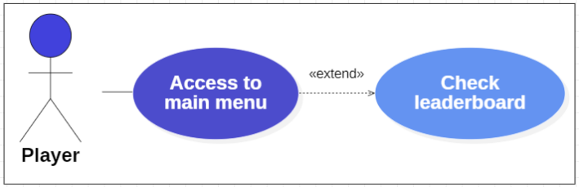Table 3.9 below shows the refinement of the " Check Leaderboard " use case.

Figure 3. 35 Check leaderboard use case diagram

Table 3. 9 "Check leaderboard" Description table

|  |  |
| --- | --- |
| **Title** | Check Leaderboard |
| **Actors** | Player |
| **Goal** | Allow the player to access and view their ranking on the leaderboard. |
| **Precondition** | The game is running, and the player has accessed the main menu. |
| **Post-condition** | The player successfully accesses and views their ranking on the leaderboard. |
| **Description of the main scenario** | 1. The player is in the main menu and decides to check their ranking on the leaderboard. 2. The player navigates to the Leaderboard option or panel within the game interface. 3. The game displays the Leaderboard panel, which showcases the rankings of players in the game. 4. The player searches his name in the leaderboard. |

**Refinement of the "Access to Profile" use case**

Since our game is a multiplayer game, each player has his own independent profile, and for that matter he can change his nickname, avatar, check profile stats such as how many matches he played and won, how many hunters he owns and what’s his favourite one, and why not sharing the game to his friends.

Figure 3.36 shows the use case diagram for the use case "Access to Profile".

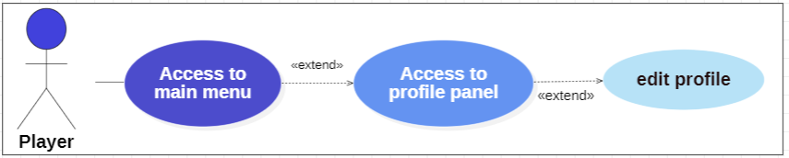

Figure 3. 36 Access to profile panel use case

The table 3.10 below shows the refinement of the "Access Profile" use case.

Table 3. 10"Access Profile" Description table

|  |  |
| --- | --- |
| **Title** | Access profile |
| **Actors** | Player |
| **Goal** | Allow the player to access their profile, where they can customize their nickname, avatar, view profile stats, share the game with friends, and manage their owned hunters. |
| **Precondition** | The game is running, and the player has accessed the main menu. |
| **Post-condition** | The player successfully accesses their profile, makes desired changes, views profile stats, and performs actions such as sharing the game with friends. |
| **Description of the main scenario** | 1. The player is in the main menu and decides to access the profile panel. 2. The player navigates to the Profile panel. 3. The game displays the Profile panel, which showcases various customization and profile management options. 4. The player edits his profile, by changing his name or avatar. 5. Check game stats. |

**Refinement of the "Start game" use case**

Before the start of the match, the player must choose between joining a random room with random players, creating a private room, or joining a private room and in either case he will have to wait for the other three remaining players to join before the match starts.

Figure 3.37 shows the use case diagram for the use case "Start game".

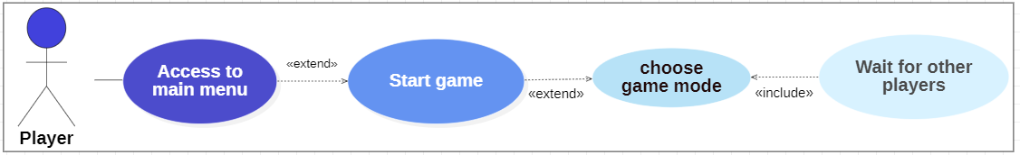The table 3.11 below shows the refinement of the "Start game" use case.

Figure 3. 37 Start game use case diagram

Table 3. 11 " Access settings" Description table

|  |  |
| --- | --- |
| **Title** | Access settings |
| **Actors** | Player |
| **Goal** | Allow the player to start a game by choosing between joining a random room with random players, creating a private room, or joining a private room. |
| **Precondition** | The game is running, and the player has accessed the main menu. |
| **Post-condition** | The player successfully starts a game by joining a room or creating a room and waits for the other to join players . |
| **Description of the main scenario** | 1. The player is on the main menu and decides to start a game. 2. The player navigates to the "Start Game" option or button within the game interface. 3. The game presents the available options for starting a game, which include:   **a. Joining a Random Room:**   * The player selects the "Join Random Room" option. * The game attempts to find an available room with other players seeking to play. * If a suitable room is found, the player is automatically placed in the room and starts playing or waits for other players to join.  1. **Creating a Private Room:**  * The player clicks on the "Create Private Room" button. * The game generates a unique room ID. * The host player waits for others to join.  1. **Joining a Private Room:**  * The player inputs the Room ID * The player clicks the "Join Private Room" button.  1. Waiting for Players |
| **Description of alternative scenario** | 3.a If the player encounters difficulties in the matchmaking :   * The game provides informative messages, that the internet connection is not stable. |

#### 

#### 3.3.2.3 Development of sprint 2

In this section, we will explore the different interfaces that have been implemented regarding the use cases we have presented so far.

**The authentication interface**

When launching the game for the first time the player must create an account, to be registered on the PlayFab backend and as that procedure is finished, he will receive a verification email to validate his account.

Once the account has been approved, the player must login and starting from the first time he will always be automatically logged in.

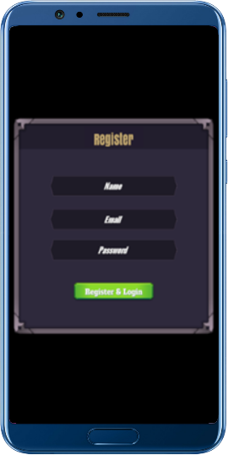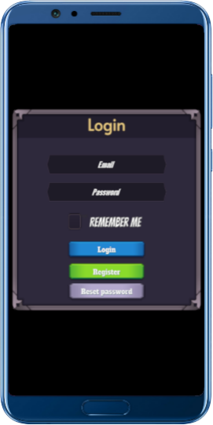

Figure 3. 38 Authentication interface

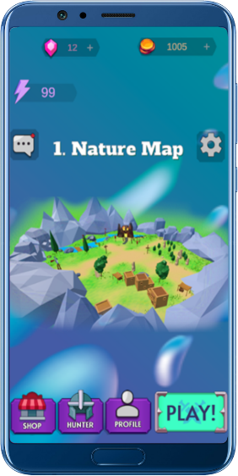

**Main menu interface**

As mentioned before in the access main menu use case the user

will go through the same experience as discussed.

Figure 3. 39

Main menu interface

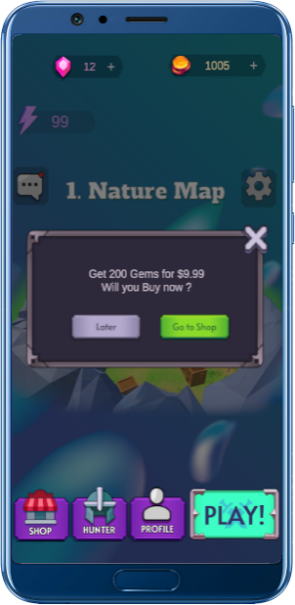**Check message of the day interface**

The click on the newsletter button will set the news panel active.

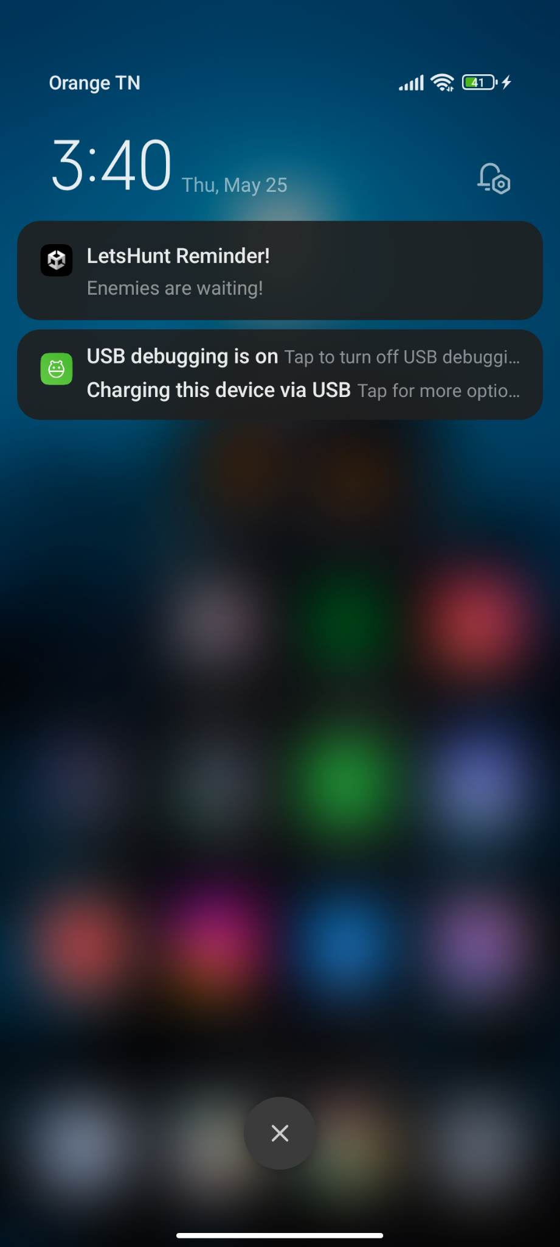

Figure 3. 40

Notification received.

Figure 3. 41

in-game message

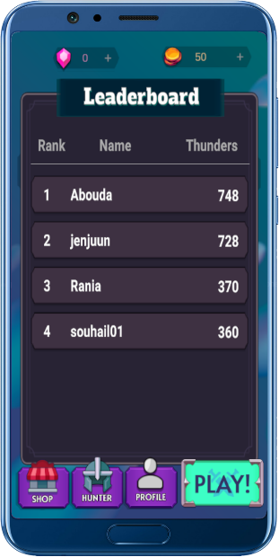**Check ranking in leaderboard**

The click on the thunder icon will set the leaderboard panel active so that the player can see all the players rankings and of course his rank.

Figure 3. 42 Leaderboard

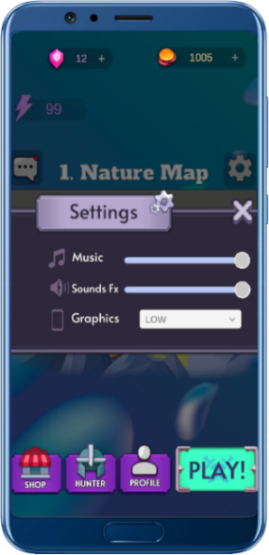

**Adjust the settings**

The player can access the settings by clicking on the settings icon, and once the panel is active, he will be able to adjust the SFX, music and graphics settings.

Figure 3. 43 Settings panel

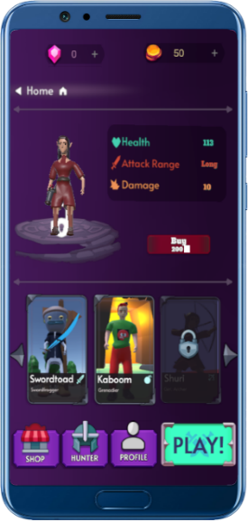

**Access to the hunter’s panel**

Since the player can buy and own game characters, the click on the hunter button will set the hunter panel active and the player will be able to either buy or select a hunter.

Figure 3. 44 Hunters panel

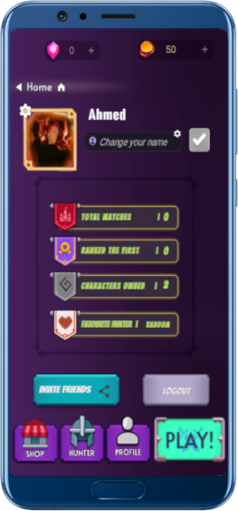

**Access to profile panel**

A multiplayer game means that the player will have an account which he can modify and represent himself through it, and that’s why we made a profile panel, where the player can modify his name and avatar and also logout, share the game and check his stats.

Figure 3. 45 Profile panel

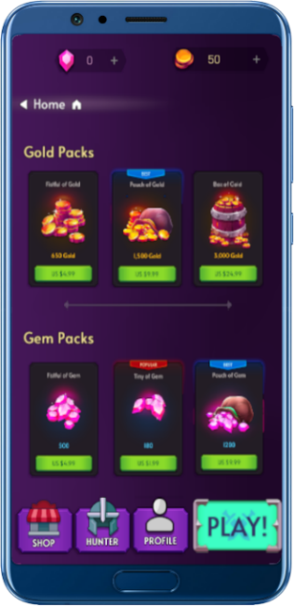

**Access the shop menu**

Using real currency, the player can buy game currencies through setting the shop menu panel active by clicking on the shop button.

Figure 3. 46 Shop panel

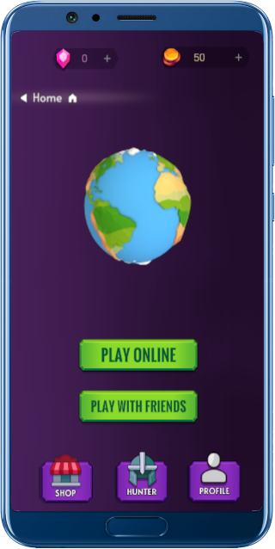**Access to matchmaking menu**

The click on the “Play!” Button will eventually set the matchmaking menu active, and that’s where the player can choose between two options, either play online with strangers, or playing with friends.

The play online button will lead the player to either directly join a room and start playing or to host an online room and wait for others random three players to join.

Figure 3. 47 Matchmaking menu

“Play with friends” button will take us to another panel where there’s two buttons.   
The click on the create room button will lead the host player to create a room and while waiting for the other player to join, a waiting panel will be set active containing a private room ID key which the host must share with his friends.

The room ID key must be inputted by the players who want to join the private room and the click on the join button will validate the connection to the private room.

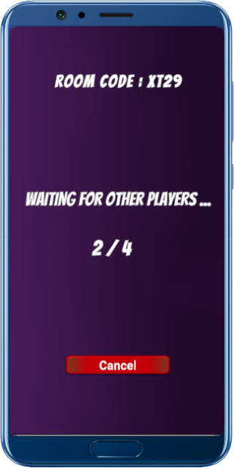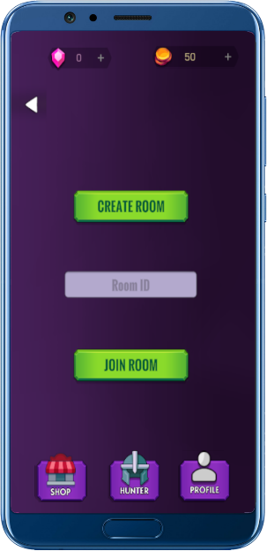

Figure 3. 49 Play with friends menu

Figure 3. 48

Waiting for other players menu

3.3.3. Sprint 3: “Animations & controls”

Focusing on programming and controls, this sprint served a significant milestone in our journey towards creating and establishing a clear vision for our game using Unity 3D and C# programming language and Photon.

The objective of this sprint is to establish the game's functionalities as mentioned, ensuring smooth player controls, and introducing the basic AI enemy controls.

Furthermore, we integrated the Photon Network which will allow us to create a good multiplayer experience, and a matchmaking system for the best player engagement.

In addition, the development of the in-game user interface played a role in enhancing the overall player experience.

#### 3.3.3.1 Detailed conception of the sprint 3

Of all phases, this one is the most important since it is responsible for blowing life into our game by linking controls, coding, and networking together.

To make this happen, we went through a well-organized work process by following the functional requirements, sprint backlog and the conception of it, and so along the way we learned the programming language C# infused with Photon and, we learned all the tricks of animating the characters and all the essentials to game development.

##### 3.3.3.1.1 Use case diagrams of the sprint 3

The programs and controls are linked to the in-game part of our game, and so down below we state the use case diagram for the in-game.

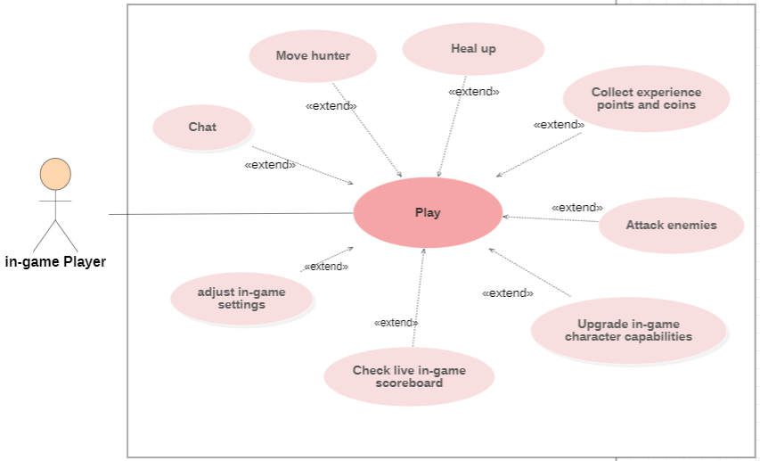

Figure 3. 50 Sprint 3 Use Case

**Refinement of the use case “Move Hunter.”**

The player can move the hunter around the map using a joystick.

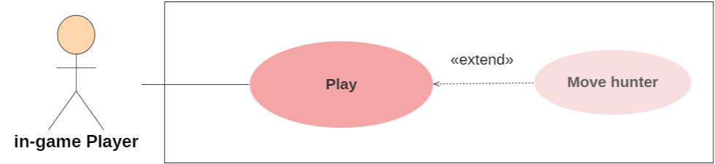

Figure 3. 51 Move hunter use case

Table 3.12 below shows the refinement of the "Move hunter" use case.

Table 3. 12 "Move hunter" Description table

|  |  |
| --- | --- |
| **Title** | Move Hunter |
| **Actors** | In-game Player |
| **Goal** | allow the player to move the hunter character within the game by utilizing a joystick control. |
| **Precondition** | The game is running, and the player has entered a match. |
| **Post-condition** | The hunter character successfully moves to the desired location on the map based on the player's input through the joystick. |
| **Description of the main scenario** | 1. The player is in gameplay and wishes to move the hunter character. 2. The player interacts with the joystick control by touching and dragging. |

**Refinement of the use case “Attack enemies”**

The main purpose of the match is to win and succeed at defeating the enemies as they evolve and become stronger, and to survive their attacks the player can attack back by letting go of the joystick to initiate the attacking animation and process.

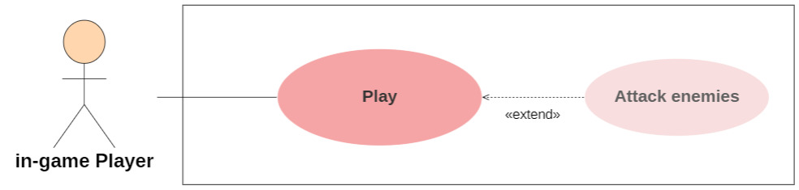

Figure 3. 52 "Attack" Use Case

Table 3.13 below shows the refinement of the "Attack enemies" use case.

Table 3. 13 "Attack" Description Table

|  |  |
| --- | --- |
| **Title** | Attack enemies |
| **Actors** | In-game Player |
| **Goal** | allow the player to initiate attacks on enemies within the game. |
| **Precondition** | The game is running, and the enemy is within the attack range of the player. |
| **Post-condition** | The player initiates an attack on the enemies. |
| **Description of the main scenario** | 1. The player is engaged in gameplay and encounters enemies within range. 2. As the player approaches the enemies and desires to attack, he releases the joystick control. 3. The attack process is executed, and the game calculates the damage dealt to the enemies based on the hunter's attributes and abilities. 4. The enemies receive the damage from the attack, and their health or status is updated accordingly. |

**Refinement of the use case “Heal up.”**

Once damaged by the enemies’, the player can know that his health is running low by checking his health bar.

To regain health, the player can stand on the healing spot.

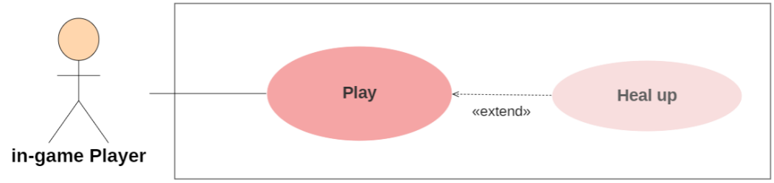

Figure 3. 53 "Heal up" Use Case

Table 3.14 below shows the refinement of the "Heal up" use case.

|  |  |
| --- | --- |
| **Title** | Heal up |
| **Actors** | In-game Player |
| **Goal** | Allow the player to regain health by standing on a designated healing spot. |
| **Precondition** | The game is running, and the player's health is below the maximum level. |
| **Post-condition** | The player successfully regains health. |
| **Description of the main scenario** | 1. The player is engaged in gameplay and notices that their hunter’s health is running low. 2. The player stands on a healing spot. 3. The player gains health. |

**Refinement of the use case “Collect experience points and coins.”**

Once a player defeats an enemy, a coin and XP will be spawned. The player can collect the XP and the coin for the XP point to boost his level during the game and the coin to be added to his balance.

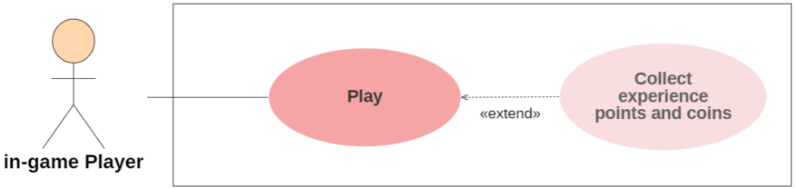

Figure 3. 54 “Collect experience points and coins” Use Case

Table 3.15 below shows the refinement of the "Collect experience points and coins" use case.

Table 3. 14 "Collect experience points and coins" Description table

|  |  |
| --- | --- |
| **Title** | Collect experience points and coins |
| **Actors** | In-game Player |
| **Goal** | allow the player to collect experience points (XP) and coins after defeating an enemy. |
| **Precondition** | The game is running, and the player has successfully defeated an enemy. |
| **Post-condition** | The player collects the experience points and coins, increasing their XP and adding the coins to their balance. |
| **Description of the main scenario** | 1. The player engages in combat with an enemy. 2. The player successfully defeats an enemy. 3. As the enemy is defeated, a coin and experience points (XP) are spawned at the location where the enemy died. 4. The player's moves the hunter over the coin, collecting it and adding it to the player's coin balance. 5. The player's hunter character moves over the XP, collecting it and adding it to the player's XP points. |
| **Description of alternative scenario** | The coins and XP can be collected by other players. |

**Refinement of the use case “upgrade in-game character capabilities.”**

This is where the player will have to use the XP points that he collected by defeating the enemies, because each time the player levels up, he can upgrade his hunter abilities.

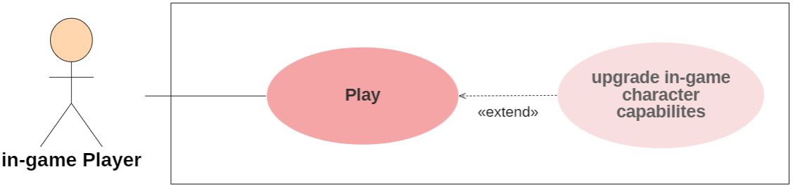

Figure 3. 55 “upgrade in-game character capabilities” Use Case

Table 3.15 below shows the refinement of the " upgrade in-game character capabilities " use case.

Table 3. 15 “upgrade in-game character capabilities” Description table

|  |  |
| --- | --- |
| **Title** | upgrade in-game character capabilities |
| **Actors** | In-game Player |
| **Goal** | allow the player to utilize the collected experience points (XP) to upgrade the abilities and capabilities of the hunter character as the player levels up within the game. |
| **Precondition** | The game is running, and the player has leveled up. |
| **Post-condition** | The player successfully upgrades the hunter character's abilities and capabilities, enhancing their performance in the game. |
| **Description of the main scenario** | 1. The player collects experience points (XP) after defeating enemies. 2. The player levels up. 3. The game displays two abilities upgrade. 4. The player chose to upgrade one ability. 5. The player’s hunter ability is upgraded. |

**Refinement of the use case “adjust in-game settings.”**

The player can adjust the SFX and music settings during the gameplay.

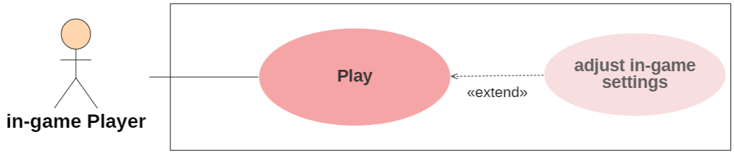

Figure 3. 56 "Adjust in-game settings" Use Case

Table 3.16 below shows the refinement of the "adjust in-game settings" use case.

Table 3. 16 "Adjust in-game settings" Description table

|  |  |
| --- | --- |
| **Title** | adjust in-game settings |
| **Actors** | In-game Player |
| **Goal** | Allow the player to adjust the sound effects (SFX) and music settings within the game during gameplay, |
| **Precondition** | The game is running, and the player is in a match. |
| **Post-condition** | The player successfully adjusts the SFX or music . |
| **Description of the main scenario** | 1. The player is engaged in gameplay and desires to adjust the music or SFX settings. 2. The player accesses the in-game settings panel by clicking on the settings icon button. 3. The player adjusts the SFX or music as he likes. |

**Refinement of the use case “chat.”**

To build a source of communication between the players, we implemented a chat system where they can chat with each other during the game.

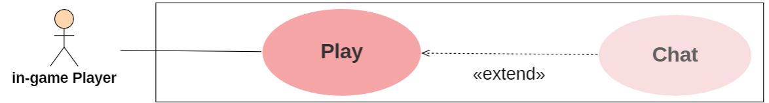

Figure 3. 57 "Chat" Use Case

Table 3.17 below shows the refinement of the "adjust in-game settings" use case.

Table 3. 17 "Chat" Description table

|  |  |
| --- | --- |
| **Title** | chat |
| **Actors** | In-game Player |
| **Goal** | Enable players to communicate with each other through a chat system during the game, ensuring interaction and challenge among players. |
| **Precondition** | The game is running, and the players have access to the in-game chat interface. |
| **Post-condition** | Players engage in communication by sending and receiving messages through the chat system. |
| **Description of the main scenario** | 1. The player desires to communicate with other players during the game. 2. The player accesses the in-game chat interface, specifically designed for text-based communication. 3. The chat interface displays the chat window, where previous messages and ongoing conversations are visible. 4. The player can enter text in the input field provided within the chat interface. 5. The player sends a text, and it is visible to all players in the room. |

##### 3.3.3.1.2 Sequence diagram of the matmaking process

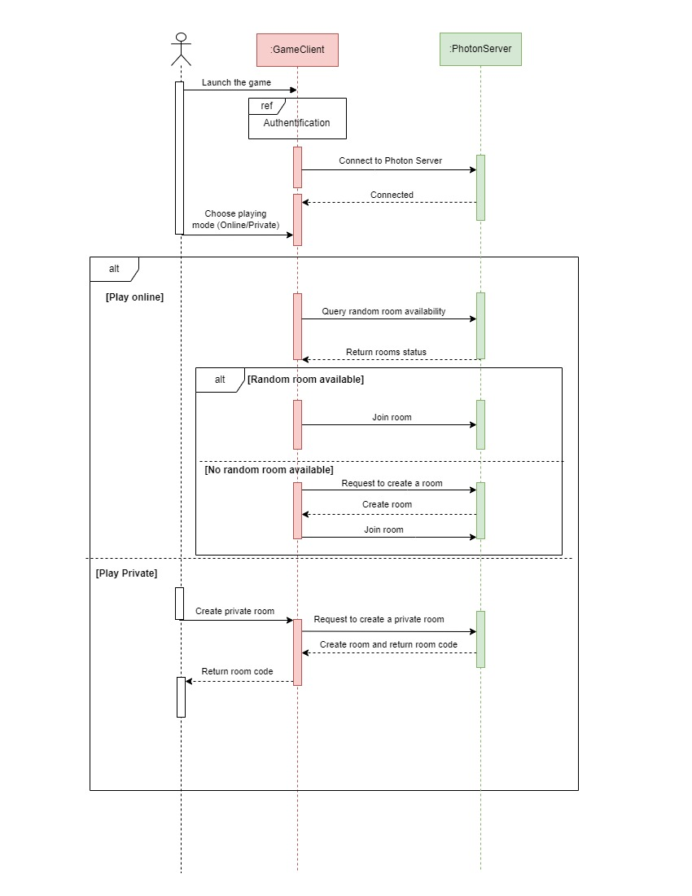

Figure 3. 58 Matchmaking process sequence diagram

**GameClient** refers to the component or module responsible for managing the game's connection to the Photon server and integrating with the PlayFab services since it handles various functionalities related to multiplayer networking, such as creating or joining game rooms, synchronizing game state between clients, and facilitating communication between players. It uses Photon Unity Networking (PUN) to establish and maintain the network connection, enabling real-time multiplayer interactions.

**Photon Server** refers to the backend server infrastructure provided by Photon Unity Networking (PUN) for real-time multiplayer networking. The Photon Server acts as a dedicated server that facilitates communication and synchronization between multiple game clients, allowing them to interact with each other in a multiplayer environment. It provides the necessary networking capabilities to support features such as player movement, game object synchronization, and real-time messaging.

#### 3.3.3.2 Development of sprint 3

In this section, we will present the principles of how we fused the coding with animation, the scenes created, and the fulfilment of the needs for this sprint, as well as the tasks.

##### 3.3.3.2.1 Animation

Unity 3D, has a rich animation system that provides:

* Easy workflow and configuration of animations for all elements in Unity, including objects, characters, and properties.
* Support for imported animation clips and animations created within Unity.
* Humanoid animation retargeting, which allows applying animations from one character model to another.
* Streamlined workflow for aligning animation elements.
* Convenient preview of animation clips, transitions, and interactions between them. This allows prototyping and previewing animations before the game code is implemented.
* Ability to animate different parts of the body with different logic.
* Overlay and masking functions for advanced animation effects.

##### 3.3.3.2.2 Animation our “Hunters”

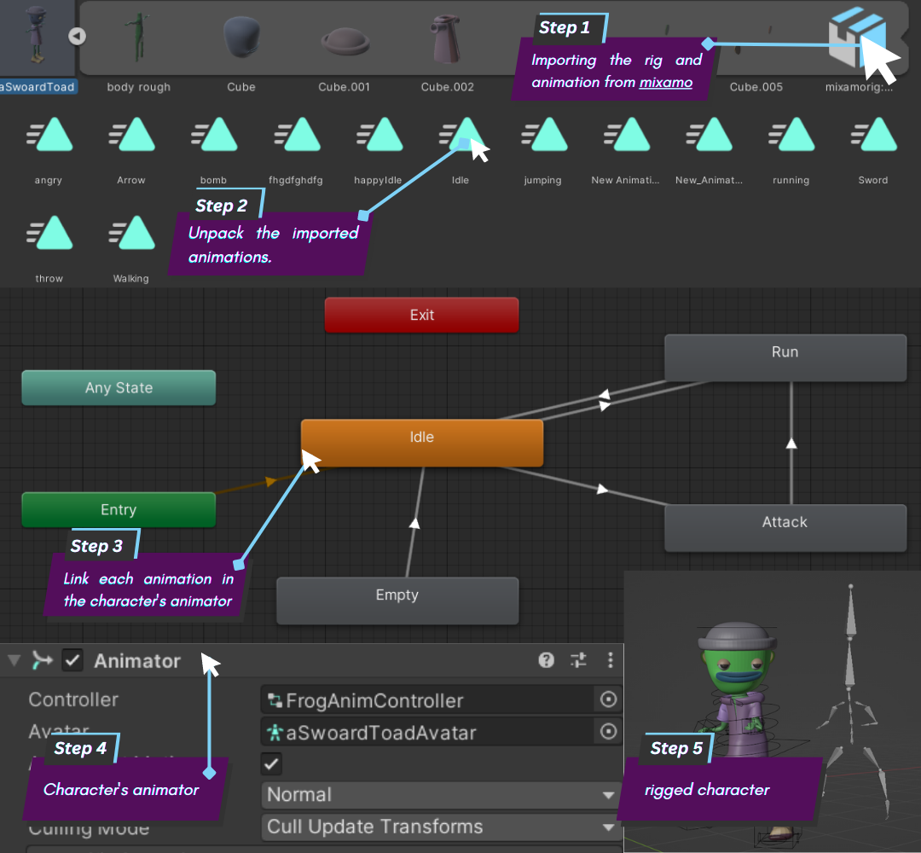

Figure 3. 59 Hunters animation process

The figure 3.59 above shows the following:

1. Humanoid animations captured by motion capture and imported from Mixamo.
2. Animations are exported and unpacked.
3. Animation clips are placed and organized within an "Animator Controller." The diagram represents a view of an Animator Controller in the Animator window. The "States" (which can represent animations or nested sub-state machines) appear as nodes connected by lines. The Animator Controller exists as an asset in the Project window.
4. When animating the character model, an Animator component is attached to it. In the illustrated Inspector view above, you can see the Animator component that has the Animator Controller and Avatar assigned to it. The animator uses them together to animate the model. The Avatar reference is necessary because it is animating a humanoid character.
5. The rigged character model (in this case, the hunter “SwoardToad”) has a specific bone configuration that is mapped to Unity's common Avatar format, and this mapping is stored as an Avatar resource within the imported character model and is also shown in the project window.

To incorporate the joystick input into the character animations, we implemented the following steps:

* **Joystick Input**: we first set up a mechanism to receive and process the joystick input from the player and that typically involves accessing the input values for both the horizontal and vertical axes of the joystick.
* **Animation Blending**: Using the Animator Controller, we created animation states for different movements, such as idle, run, and attack and by blending between these animation states through code, we ensured smooth transitions between different movement speeds based on the joystick input.
* **Animator Parameters**: Within the Animator Controller, we defined a parameter for each state, for example the running state contains a "MovementSpeed," of type Float. That parameter acted as a control variable for the animation transitions and speed.

By following these steps, the character animations seamlessly synchronized with the player's joystick input. As the player moved the joystick, the Animator Controller responded with launching the movement animation, and when there’s an enemy within the hunter’s range the joystick is released to trigger the attack animation.

**Unity Asset Store:**

The Unity Asset Store is a collection of both free and commercial resources created by Unity Technologies and community members. It offers a wide range of assets, including textures, models, animations, complete project examples, tutorials, and editor extensions.

For our project, we have utilized models, textures, and materials from the Unity Asset Store. These include assets such as movement Joystick, buildings, sound effects, and enemies. By incorporating these assets, we were able to create a realistic scene without spending a significant amount of time on modeling from scratch. This allowed us to save time and focus more on other aspects of our project.



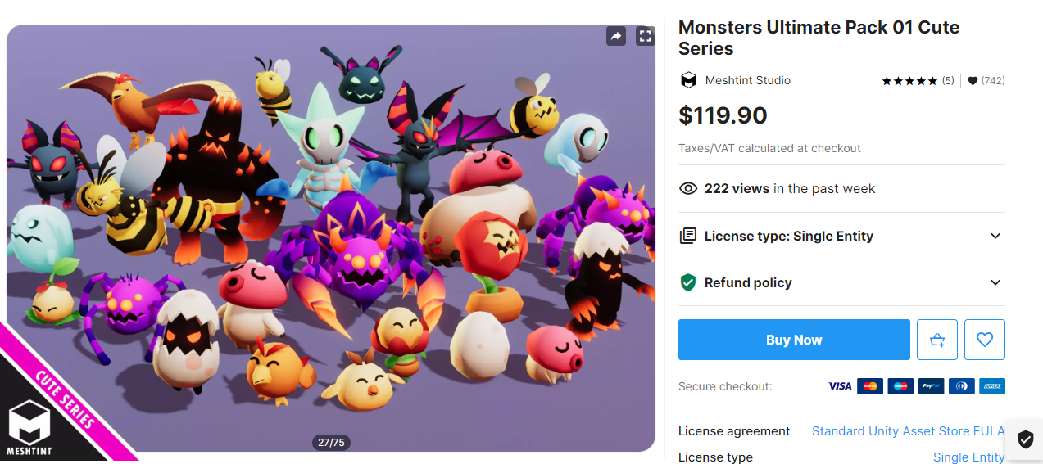Figure 3. 60 Unity Asset Store logo

Figure 3. 61Monsters pack

**Artificial intelligence in video games:**

Artificial intelligence in video games is used to provide a high-quality experience, for example, by giving non-player characters behavior that closely resembles that of a human, logical interaction, or by limiting the program's skills to give the player a sense of fairness.

Most people probably imagine that the majority of games released in the past two years have highly sophisticated AI for all non-player characters, creatures, or animals (often called bots). However, many game developers are hesitant to integrate advanced AI into their games for fear of losing control over the overall player experience. In fact, the goal of AI in video games is not to create an unbeatable entity for players to fight against, but rather to maximize player engagement and enjoyment over extended periods of time.

**The use of AI with enemies:**

**Moving and navigating between destinations:**

When it comes to programming enemies as bots in video games, one effective method is to use a technique called NavMesh. This approach allows the enemies to navigate the game world by moving between specific points that have been predetermined. Moreover, these enemies are designed to become alert and engage with the player who is closest to them once that player enters a specific range that triggers their attention.

**NavMesh in Unity:**

The Unity NavMesh consists of the following elements:

**NavMesh** (short for Navigation Mesh) is a data structure that describes the walkable surfaces of the game world, allowing for finding a path from one accessible location to another within the game world. The data structure is built or baked from the level geometry.

**The NavMesh Agent** component helps in creating characters that navigate towards their goals. The agents reason about the game world using the NavMesh and know how to avoid each other and moving obstacles.

**The Off-Mesh Link** component allows for incorporating navigation shortcuts that cannot be represented using walkable surfaces. For example, jumping over a fence or opening a door before crossing it can be described as Off-Mesh links.

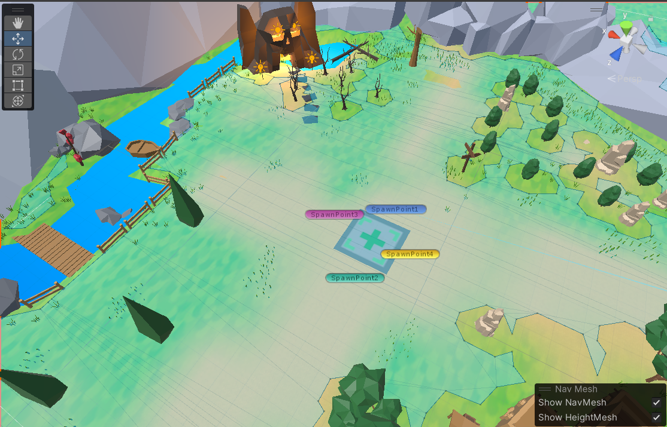**The NavMesh Obstacle** component is used to describe moving obstacles that agents must avoid while navigating the world. For instance, a barrel controlled by the physics system. As the obstacle moves, agents do their best to avoid it. However, once the obstacle becomes stationary, it creates a hole in the NavMesh so that agents can change their path to go around it. If the stationary obstacle blocks the path, agents can find an alternative route.

Figure 3. 62 NavMesh in the Map

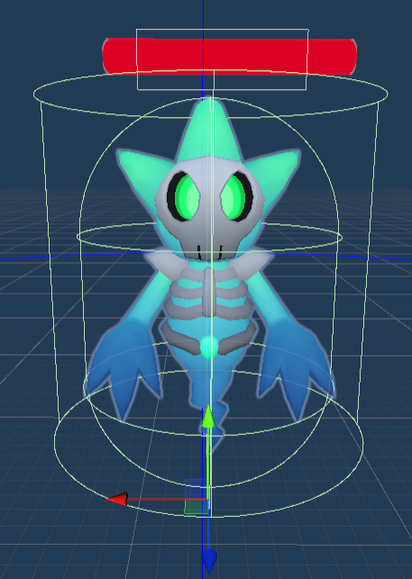

Figure 3. 63 NavMesh Agent Collider

##### 3.3.3.2.3 Implementing Photon Network set-up

In the development of “Let’s Hunt,” we integrated Photon Network as a component to our online networking infrastructure by utilizing Photon's APIs and extensive documentation until we successfully implemented real-time multiplayer functionality, enabling players to connect, interact, and compete in thrilling gameplay sessions.

First, we created an account in photonengine.com so we can create our application.

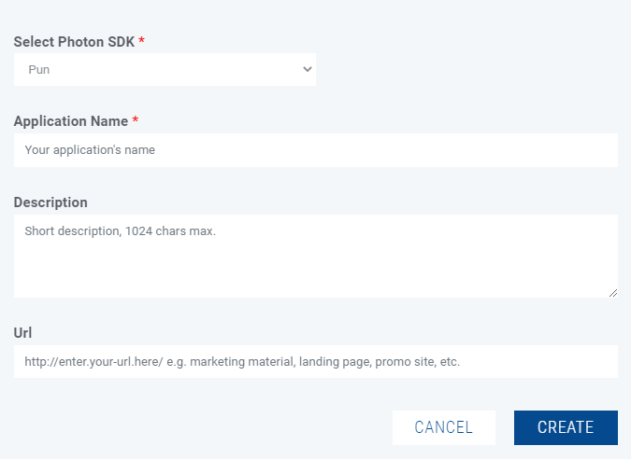

Figure 3. 64 Photon Network Application Form

Then, after importing the photon SDK into unity, we inserted the application and chat IDs to Unity.

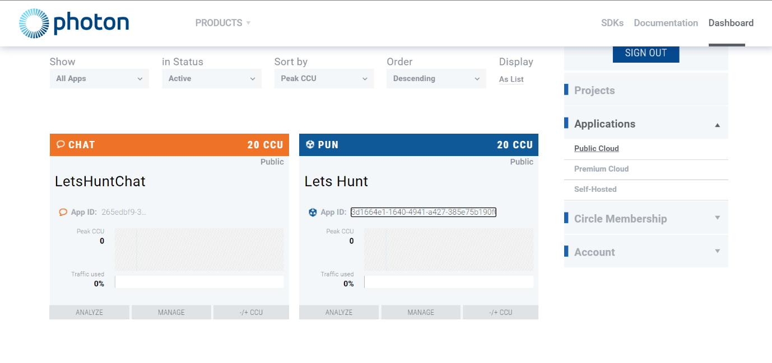

Figure 3. 65 Photon Dashboard

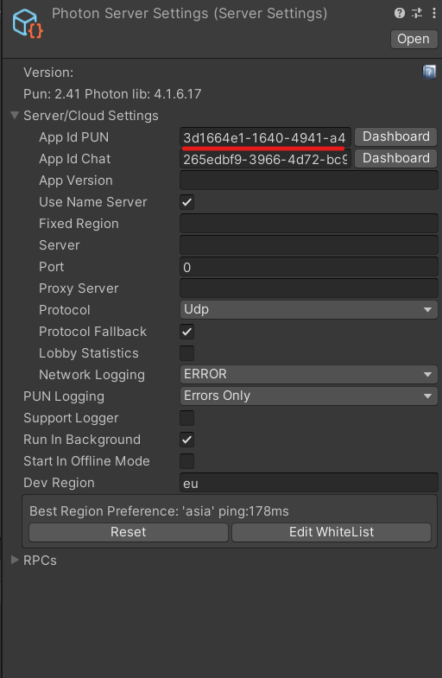

Figure 3. 66 Implement Photon in Unity

Once the SDK and IDs are set, we started programming the functionalities using C# programming language infused by photon’s and unity’s libraries.

##### 3.3.3.2.4 PlayFab implementation

We incorporated PlayFab as a backend solution to enhance the user experience.

PlayFab allowed us to integrate player authentication, enabling users to securely create accounts and access personalized game profiles and through the PlayFab's flexible database system, we efficiently stored and retrieved player data, such as “Coins”, “Gems”, “Thunders”, etc...

Using PlayFab's APIs, we managed to enable the player’s authentication and a secure data synchronization across different devices, allowing players to effortlessly switch platforms without losing their progress and profile data.

To add PlayFab to our game we accessed PlayFab.com and signed up in the official website and then we created our studio, called “Lets Hunt.”

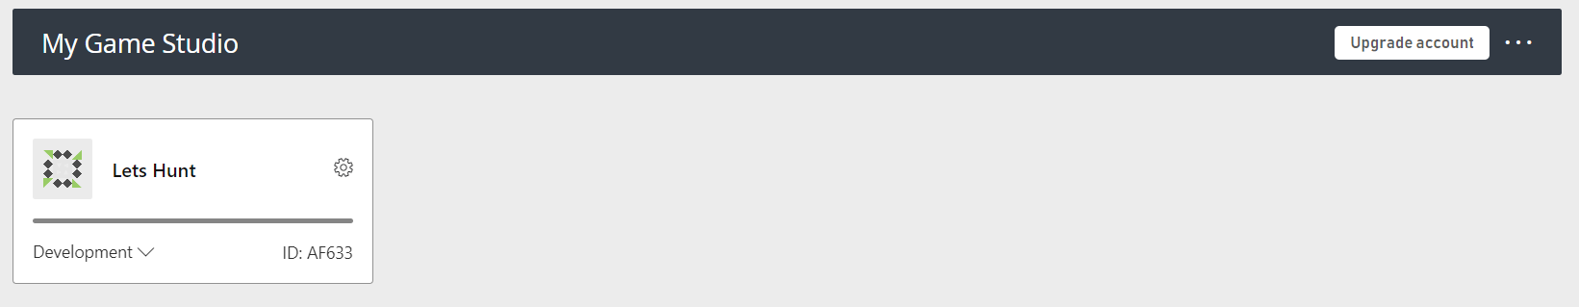

Figure 3. 67 PlayFab Applications Dashboard

Then we installed the PlayFab’s SDK and installed it to unity and so we got this interface.

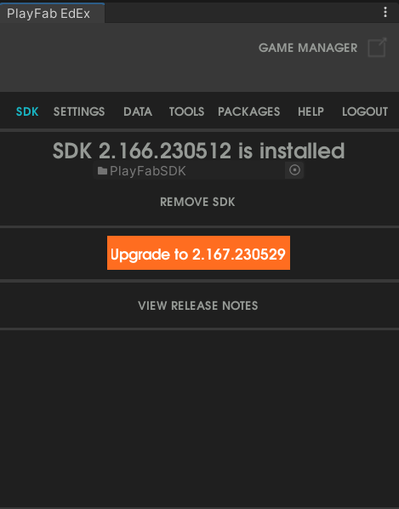

Figure 3. 68 PlayFab in Unity

To make PlayFab API calls we should use its library in our C# scripts.

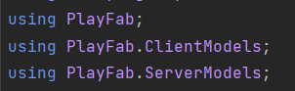

Figure 3. 69 imported librairies

And this is the interface of the dashboard where we can manage players accounts, email templates, currency, and news.

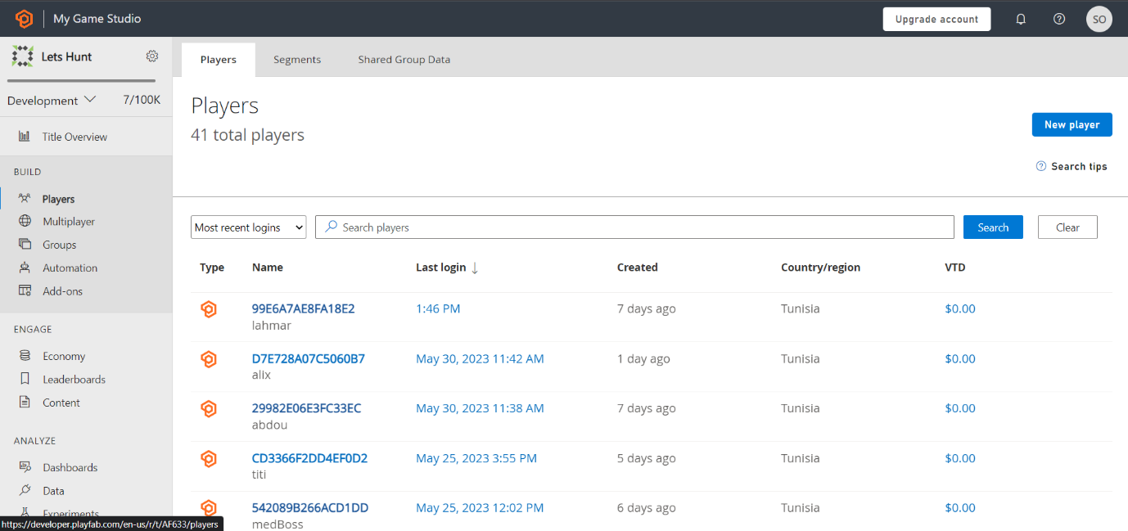

Figure 3. 70 PlayFab Dashboard

##### .3.3.2.5 In-game User Interface

The in-game user interface went through many stages, as we added more functionalities to our game. The figure below states all the functionalities that our in-game interface provides.

Figure 3.71 indicate the game interface.

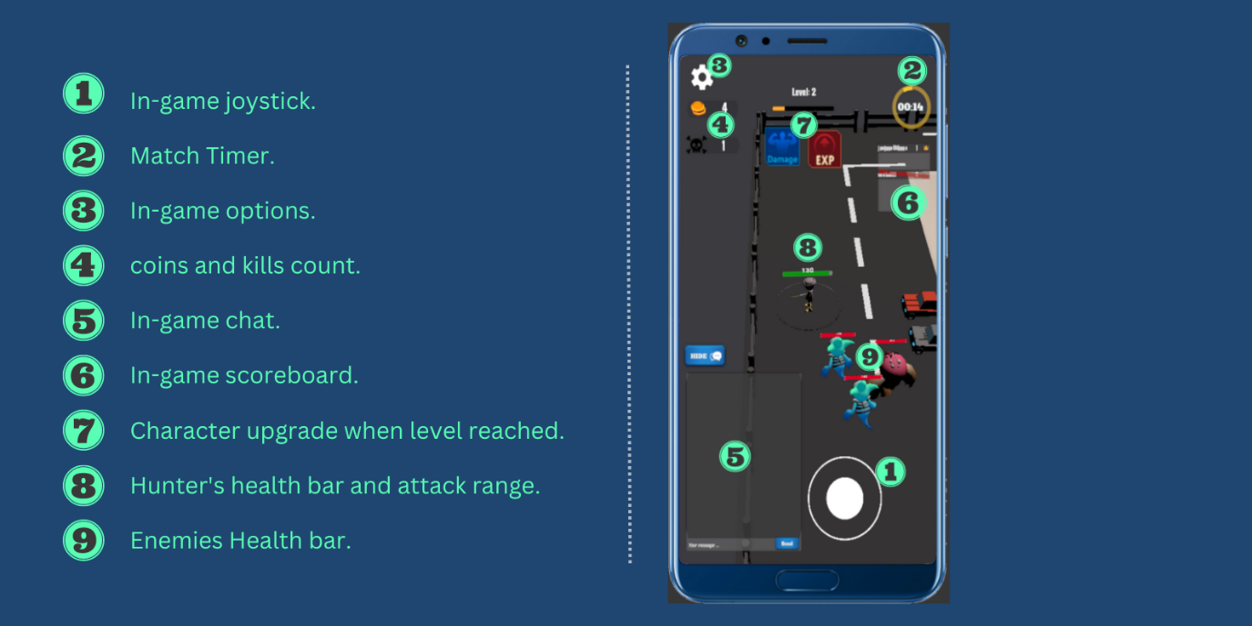

Figure 3. 71 Game User Interface

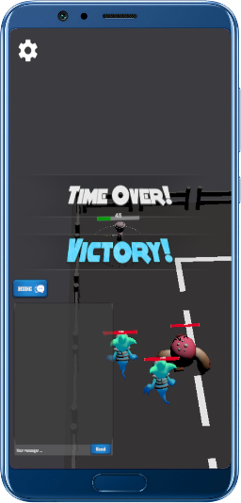

**The victory interface**

Once the time is over, the first ranked player will be announced to be the winner of the match and will see a victory message accompanied by a Panel.

Figure 3. 72

Victory interface

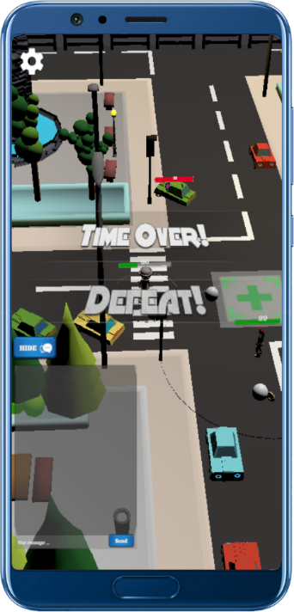

Figure 3. 73

Loss interface

**The loss interface**

Once the timer has run out, the alive players with a low rank will be announced defeated.

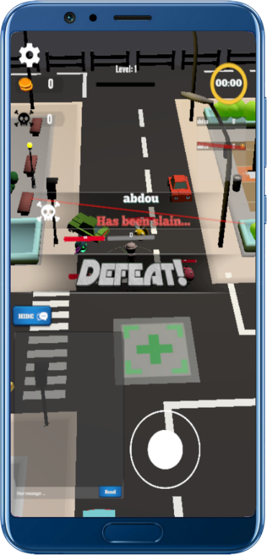

**Player eliminated**

Once a player is eliminated, all the players will be notified about it by receiving a message that says, “Player, has been eliminated”.

Figure 3. 74 Player eliminated panel

3.3.4 Sprint 4 “Authentication & Game Enhancement”

The goal of this sprint is to enhance the game experience by implementing authentication and login functionality, adding sound effects (SFX) and music, final testing and debugging of the game, creating the publish platform and finally putting it for publication.

#### 3.3.4.1 Detailed conception of sprint 4

Even though Google Play Services could’ve provided us with a more fluent and secure login process, since we published the game a little too late, it will be in review for more than a month.

“Let’s Hunt” is an online game, and playing online must be accompanied by a well-developed authentication service, and as explained in the previous sprint, we utilized the platform PlayFab to achieve it.

In the next page, we state the sequence diagram of the authentication process which explains how it is smoothy running.

Right after building the authentication, following the user story, we added an Audio Manager to our game and made it controllable by the settings menu.

Figure 3.71 below indicate the sequence diagram of authentication process

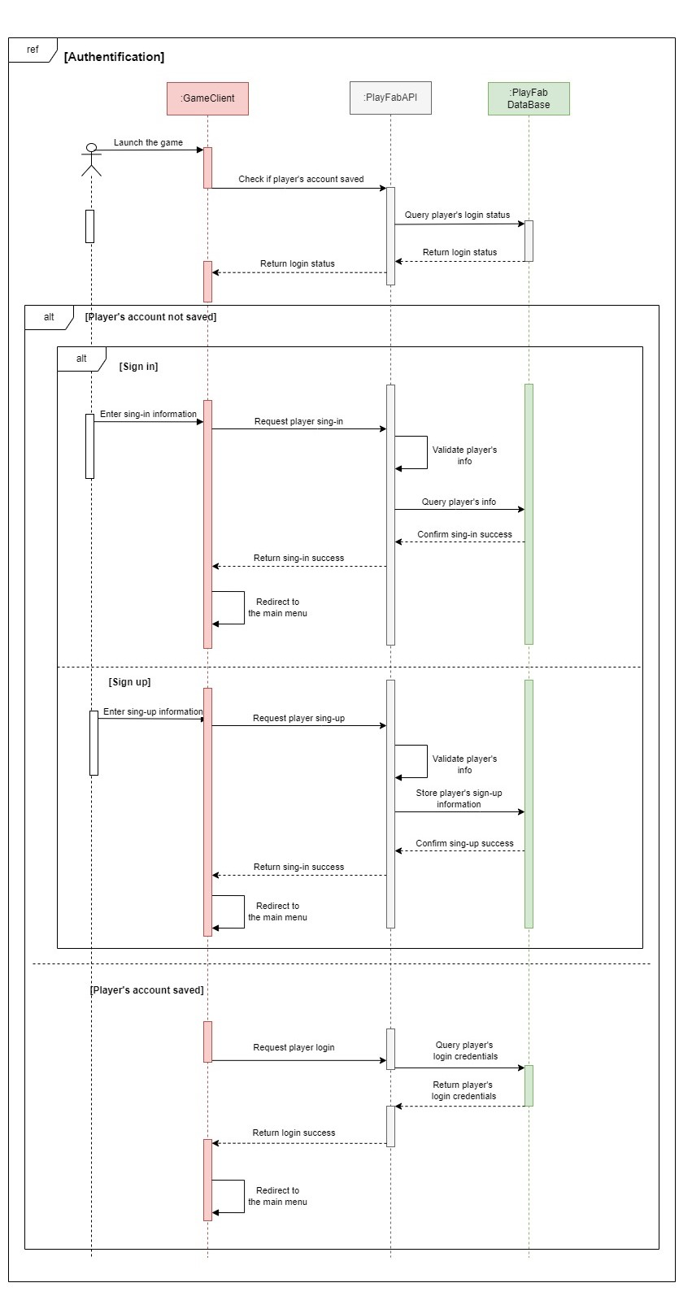

Figure 3. 75 Sequence Diagram of Authentication

#### 3.3.4.2 Development of sprint 4

##### 3.3.4.2.1 PlayFab utilization

PlayFab was integrated into the game to provide backend services for player management, authentication, and cloud data storage. It is responsible for infrastructure that handles player registration, login, game currency management, and player data and statistics storage.

* **Player Registration:**

- The game incorporates PlayFab's registration functionality to allow players to create “Let’s Hunt” accounts.

- When a player registers, they provide necessary information such as username, email, and password.

- PlayFab handles the registration process by securely storing the player's account details in its database.

- After successful registration, a confirmation email is sent to the player's registered email address to verify their account.

* **Login and Token-based Authentication:**

- Once registered, players can log into the game using their email and password.

- PlayFab's authentication system securely verifies the player's credentials and generates an authentication token.

- The authentication token is then stored locally on the player's device.

- For subsequent logins, the game automatically retrieves and uses the stored token to authenticate the player, eliminating the need for manual login each time.

* **Game Currency Management:**

- PlayFab provides a reliable mechanism for managing in-game currency.

- It offers features such as virtual currency and virtual economy management.

- The game integrates with PlayFab's currency management system to handle player's game currency transactions, such as earning or spending game currency for in-game purchases or rewards.

* **Player Data and Statistics Storage:**

- PlayFab's data storage services are utilized to store and manage player-specific data and statistics, and this enables players to access their game data and statistics from any device, as the information is securely stored on PlayFab's servers.

By integrating PlayFab into the game, it provided an amazing experience for players.

The registration process ensures that each player has a unique account, and the confirmation email adds an extra layer of account verification and security. The token-based authentication eases the login process, allowing players to access their accounts at any time while ensuring reliable currency management and player data and statistics are securely storing on the server.

##### 3.3.4.2.2 Implementing Game Audio

To add the audio in the game, an Audio Manager was implemented which serves as a central controller for managing sound effects and music throughout the game and there’s various methods to handle audio playback and volume control.

To integrate the Audio Manager into the game, an instance of the Audio Manager class was created and instantiated during the game's initialization phase and this instance is then accessible from other game components and scripts to control audio playback and volume by utilizing the Audio Manager's methods, sound effects and music can be played at appropriate times and the volume can be adjusted to suit the player's preferences.

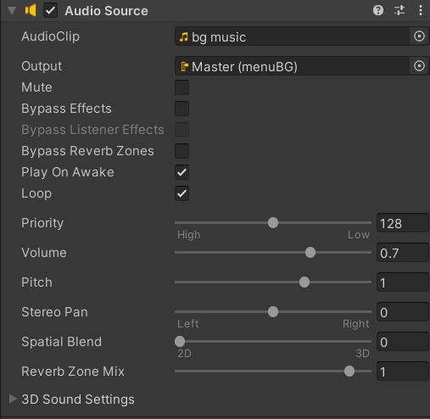

Figure 3. 76 Audio Source in Unity

#### 3.3.4.3 Game Deployment

Due to a delay in the game's development, we were unable to deploy it on the Google Play Store. As an alternative, we have created a single-page website using Angular.

The website is divided into four sections: About, Trailer, Download, and Contact.

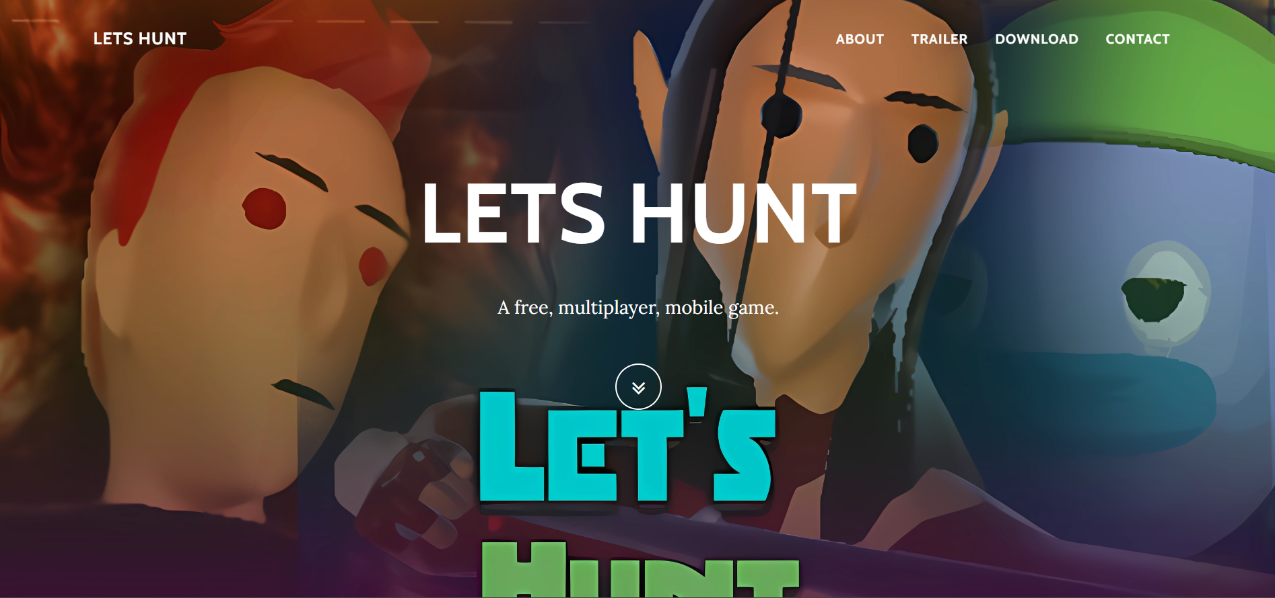

Figure 3. 77 Website Interface

* **About**: In the About section, we provide a comprehensive description of the game. This includes details about the game's concept, storyline, characters, and gameplay mechanics. We aim to engage visitors by highlighting the unique features and exciting aspects of the game.

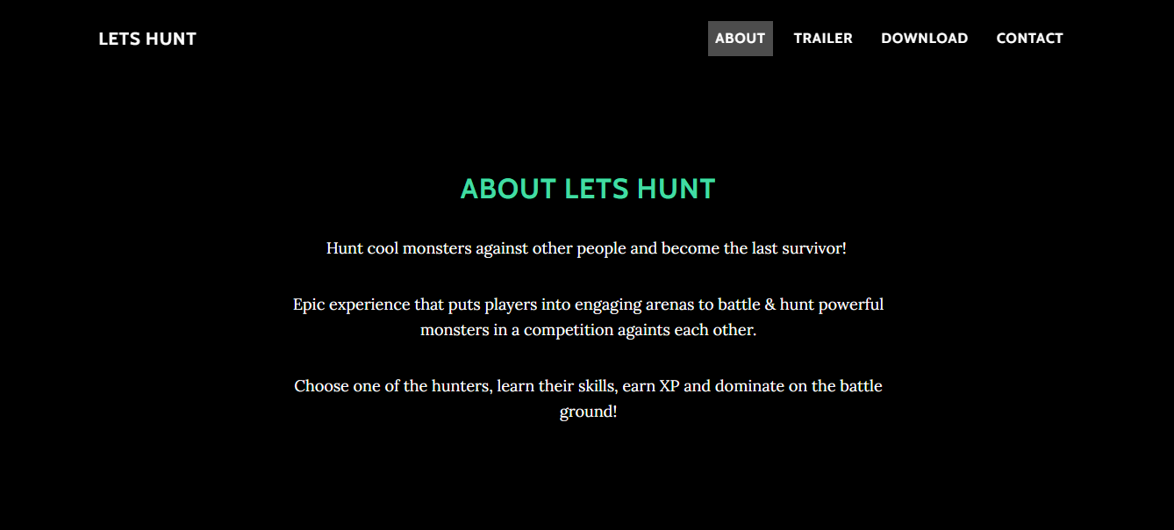

Figure 3. 78 "About" Page

* **Trailer**: The Trailer section features a short video that serves as a captivating trailer for the game. This video showcases gameplay footage, visually stunning scenes, and thrilling moments to give visitors a taste of the game's immersive experience. Visitors can watch the trailer directly on the website to get a glimpse of what the game has to offer.

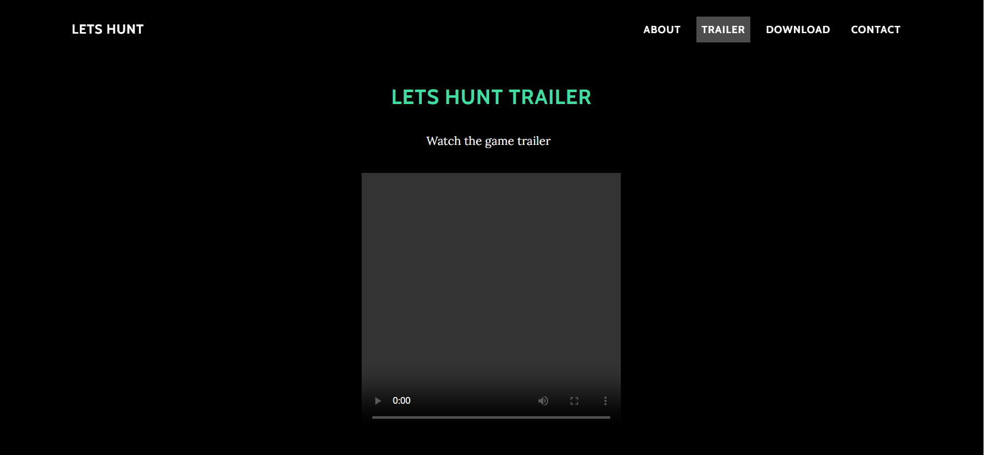

Figure 3. 79 "Trailer" Page

* **Download**: The Download section offers a button where visitors can download the game's APK file. By clicking on the download button, visitors will initiate the download process, allowing them to install the game mode APK on their devices. This provides an alternative method for players to access and enjoy the game, even without it being available on traditional app stores.

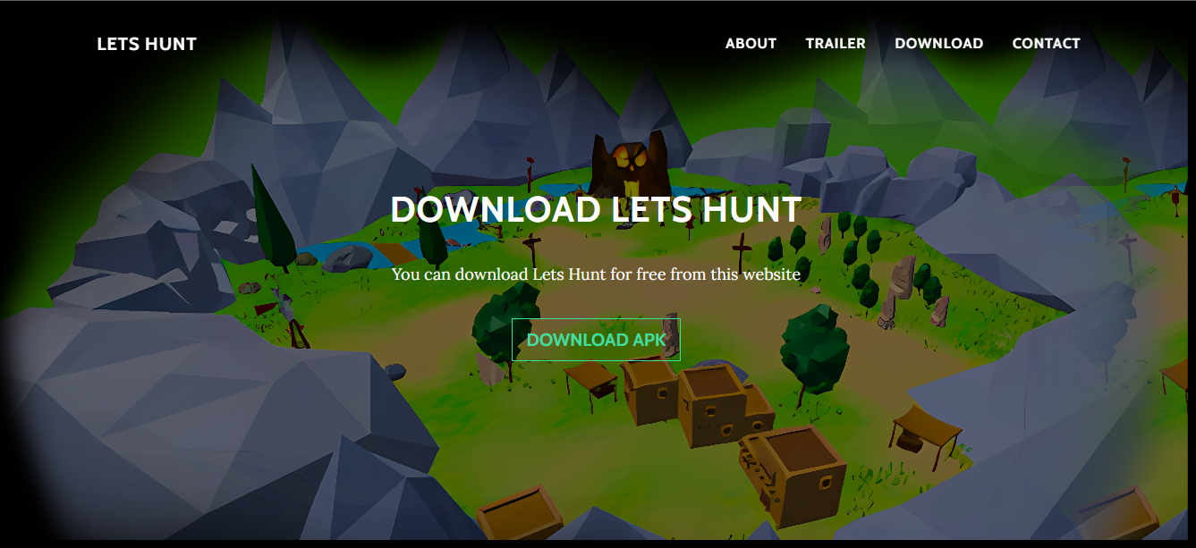

Figure 3. 80 "Download" Page

* **Contact**: The Contact section provides a form through which visitors can reach out to us. The form typically includes fields for their name, email address, and a message box where they can provide feedback, ask questions, or express any inquiries they may have. This allows for direct communication and enables us to address any concerns or engage with potential players.

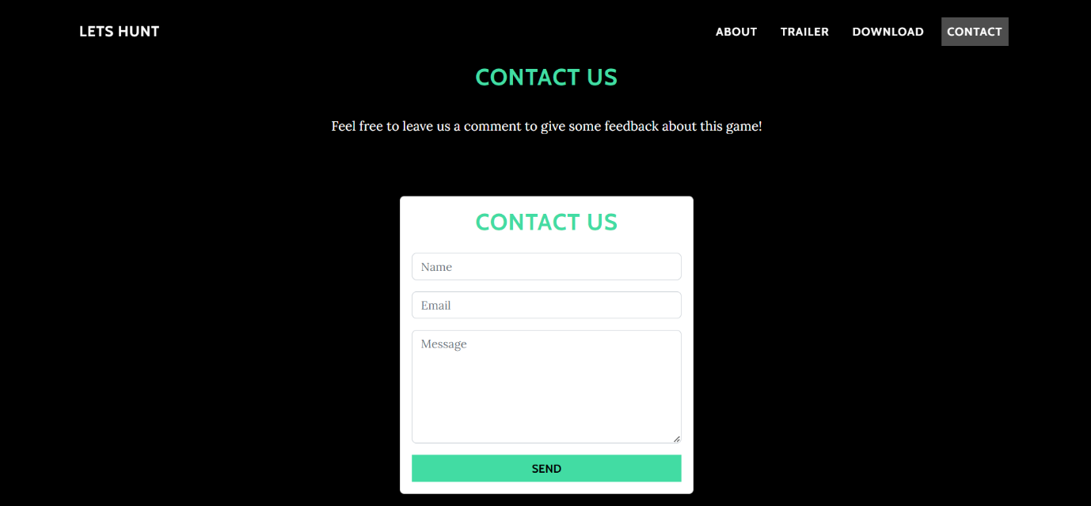

Figure 3. 81 "Contact Us" Page

In our website, we have implemented a Reset Password page as part of the user account management functionality. This page allows users to reset their passwords if they have forgotten or need to update them. The Reset Password feature is implemented using the PlayFab API, which provides robust user authentication and account management capaies.

On the Reset Password panel in the game, users can enter their registered email address associated with their game account. Upon submission, the page communicates with the PlayFab API to initiate the password reset process. The PlayFab API verifies the user's email address and sends a password reset link or token to the provided email.

Once the user receives the password reset link, they can click on it to be redirected to a secure page where they can enter a new password. The new password is then securely transmitted to the PlayFab API, which updates the user's account with the new password, ensuring their account remains protected.

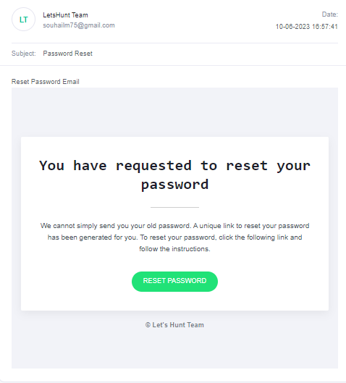

Figure 3. 82 Reset Password Email

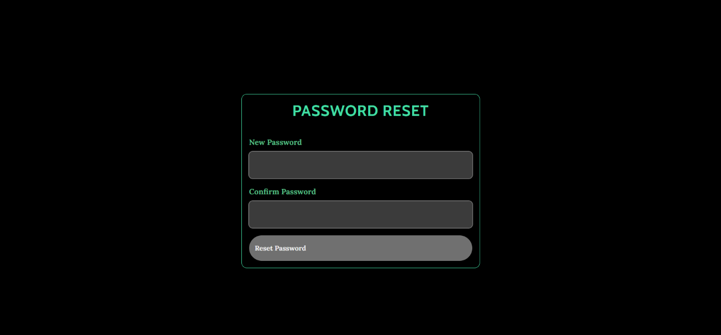

Figure 3. 83 "Reset Password" Page

**General Conclusion**

The CGI STUDIO company entrusted us with the subject of our end-of-year project, which consists of designing, developing, and creating a video game called "Lets Hunt".

We are very satisfied and proud of our work because we have achieved our objectives, and we are grateful for the opportunity to work on this project.

This report presents all the steps required to create a 3D online mobile video game.

In this context, we used the Scrum methodology, which helped us organize the work.

We then proceeded with the phase of specifying the requirements and general design and modeling, where we discussed the various technologies used.

We developed our game over four sprints.

This project provided us with a great opportunity to deepen and enrich our professional and personal knowledge, as well as acquire innovative technologies such as Unity.

Although our solution meets the company's time requirements, it could be further improved to help CGI STUDIO achieve its long-term vision.

Additional features will be added to make the game more immersive and enjoyable.

# Netography

[1] <https://en.wikipedia.org/wiki/Functional_requirement>

[2] <https://en.wikipedia.org/wiki/Non-functional_requirement>

[3] <https://www.visual-paradigm.com/guide/uml-unified-modeling-language/what-is-activity-diagram/>

[4] [https://www.visual-paradigm.com/guide/uml-unified-modeling-language/what-is-activity-diagram](https://www.visual-paradigm.com/guide/uml-unified-modeling-language/what-is-activity-diagram/#:~:text=What%20is%20Activity%20Diagram%3F%20Activity%20diagram%20is%20another,the%20flow%20from%20one%20activity%20to%20another%20activity.)

[5] <https://en.wikipedia.org/wiki/Unity_(game_engine)>

[6] <https://en.wikipedia.org/wiki/Visual_Studio>

[7] <https://en.wikipedia.org/wiki/Blender_(software)>

[8] <https://en.wikipedia.org/wiki/Mixamo>

[9] <https://www.redhat.com/sysadmin/sysadmin-tools-diagrams>

[10] <https://www.techtarget.com/whatis/definition/Photoshop>

[11] https://learn.microsoft.com/en-us/gaming/playfab/what-is-playfab

[12 ]<https://doc.photonengine.com/fusion/current/getting-started/fusion-intro>

[13] <https://webbrains.com/courses/programming-languages/c-sharp-language>

[14] https://www.javatpoint.com/um

# Bibliography

2023, Microsoft Playfab. *Azure PlayFab documentation*. 2023.

Microsoft, PlayFab 2023. *Azure PlayFab documentation*. s.d. <https://learn.microsoft.com/en-us/gaming/playfab/>.

NewZoo. «Newzoo Global Games Market Report | Free Version.» 2022.

Photon. *Fusion Introduction*. s.d. <https://doc.photonengine.com/fusion/current/getting-started/fusion-intro>.

Technologies., Unity. *Unity Documentation*. 2021. <https://docs.unity3d.com/Manual/UnityManual.html>.

|  |  |
| --- | --- |
| Abstract:  *Our project aims to develop an engaging and competitive open-world 3D mobile game, titled "Let's Hunt." The game is set in a low-poly, third-person perspective with elements of RPG, battle royale, and survival genres. The objective is to provide players with an immersive experience while promoting responsible gaming practices.*  *In "Let's Hunt," four players are spawned on an isolated map and must fight AI-generated bot enemies for survival. As players eliminate enemies, they collect coins and XP to enhance their abilities. The game progressively increases the difficulty of enemies, challenging players to adapt and strategize.*  Keywords:  *Mobile, Video Game, Online, Multiplayer, Game Development,3D Modeling.* | A picture containing black, darkness  Description automatically generated  PFE-2022/2023 |